Name: Lujain Zia

Roll no: 2023-BSE-034

Date: December 24, 2025

Lab 12

Task 0 Lab Setup (Codespace & GH CLI)

* Create Codespace & connect:

# create or open codespace via GH CLI (example)

gh repo create CC_<YourName>_<YourRollNumber>/Lab12 --public

gh codespace create --repo <user_name>/Lab12

gh codespace list

* gh codespace ssh -c <your_codespace_name>

Save screenshot as: task0_codespace_create_and_list.png — output showing repo creation/codespace list.

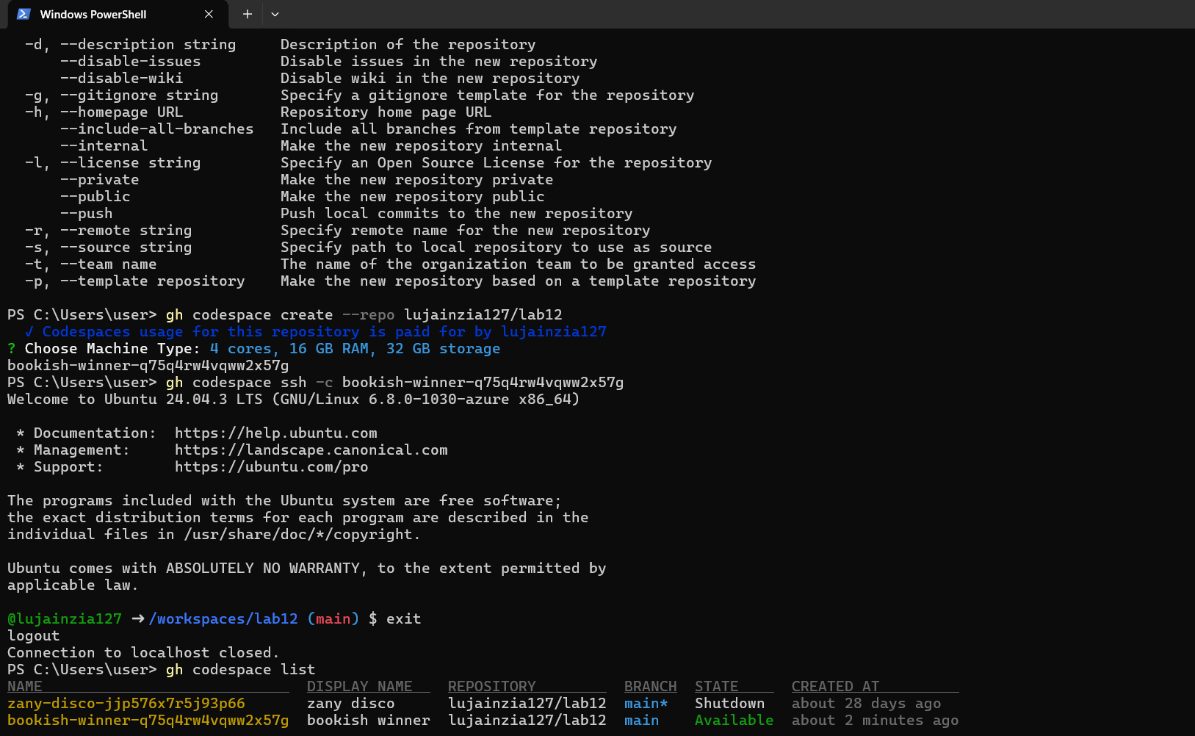

Save screenshot as: task0_codespace_ssh_connected.png — terminal inside the Codespace shell after ssh.

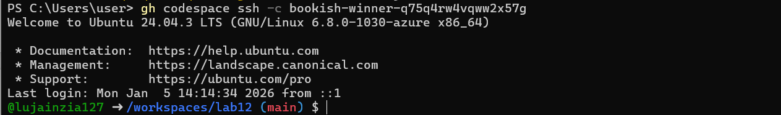

Task 1 — Organize Terraform code into separate files

1. Create the initial project structure:

mkdir -p ~/Lab12cd ~/Lab12

Save screenshot as: task1_project_directory.png — terminal showing directory creation.

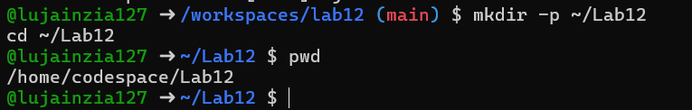

1. Create all required files:

touch main.tf variables.tf outputs. tf locals.tf terraform.tfvars entry-script.sh

Save screenshot as: task1_files_created.png — terminal showing all files created (use ls -la).

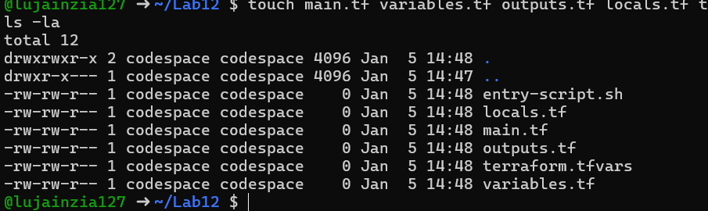

1. Create variables.tf with the following content:

variable "vpc_cidr_block" {}variable "subnet_cidr_block" {}variable "availability_zone" {}variable "env_prefix" {}variable "instance_type" {}variable "public_key" {}variable "private_key" {}

Save screenshot as: task1_variables_tf.png — content of variables.tf file.

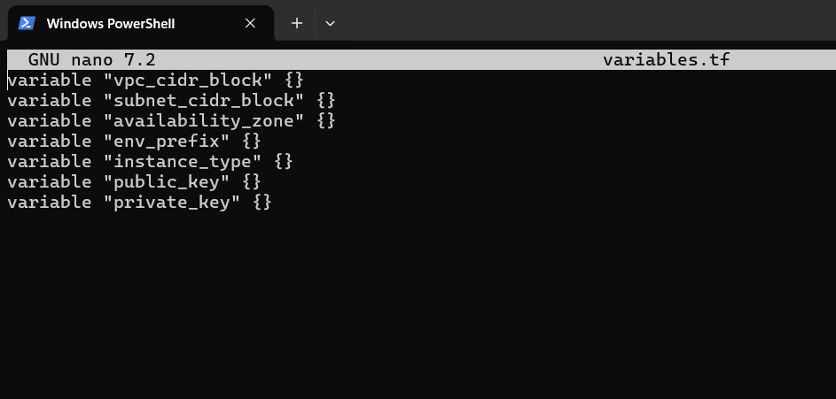

1. Create outputs.tf with the following content:

output "aws_instance_public_ip" {

value = aws_instance.myapp-server.public_ip

}

Save screenshot as: task1_outputs_tf.png — content of outputs.tf file.

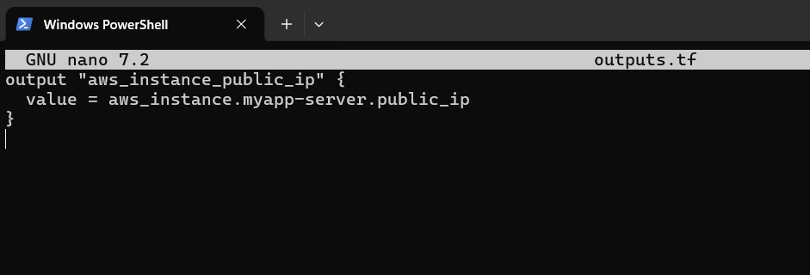

1. Create locals.tf with the following content:

locals {

my_ip = "${chomp(data.http.my_ip.response_body)}/32"

}

Save screenshot as: task1_locals_tf.png — content of locals.tf file.

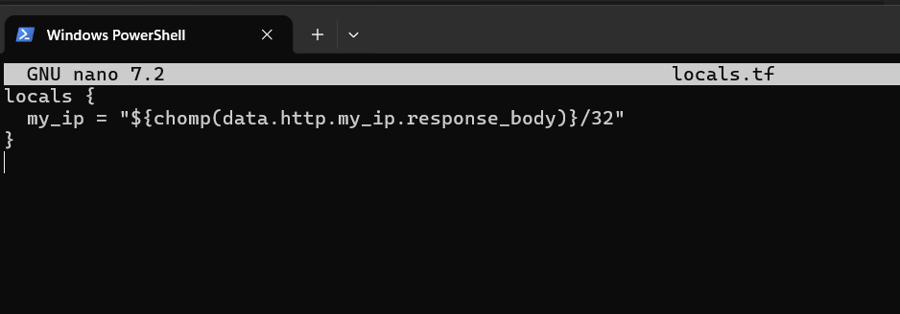

1. Create terraform.tfvars with the following content:

vpc_cidr_block = "10.0.0.0/16"subnet_cidr_block = "10.0.10.0/24"availability_zone = "me-central-1a"env_prefix = "dev"instance_type = "t3.micro"public_key = "~/.ssh/id_ed25519.pub"private_key = "~/.ssh/id_ed25519"

Save screenshot as: task1_terraform_tfvars. png — content of terraform.tfvars file.

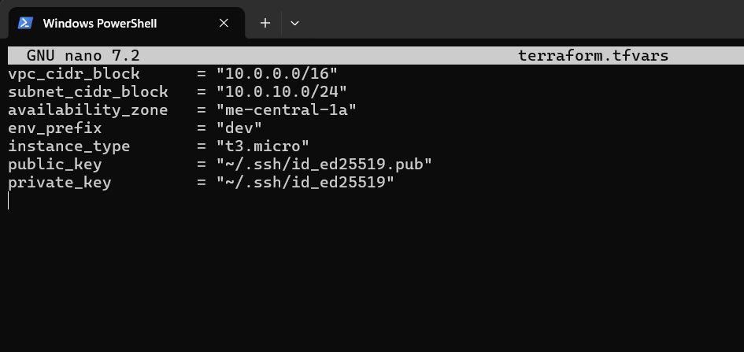

1. Create main.tf with the following content:

provider "aws" {

shared_config_files = ["~/.aws/config"]

shared_credentials_files = ["~/.aws/credentials"]

}

resource "aws_vpc" "myapp_vpc" {

cidr_block = var.vpc_cidr_block

tags = {

Name = "${var.env_prefix}-vpc"

}

}

resource "aws_subnet" "myapp_subnet_1" {

vpc_id = aws_vpc.myapp_vpc.id

cidr_block = var.subnet_cidr_block

availability_zone = var.availability_zone

tags = {

Name = "${var.env_prefix}-subnet-1"

}

}

resource "aws_default_route_table" "main_rt" {

default_route_table_id = aws_vpc.myapp_vpc.default_route_table_id

route {

cidr_block = "0.0.0.0/0"

gateway_id = aws_internet_gateway.myapp_igw.id

}

tags = {

Name = "${var.env_prefix}-rt"

}

}

resource "aws_internet_gateway" "myapp_igw" {

vpc_id = aws_vpc.myapp_vpc.id

tags = {

Name = "${var.env_prefix}-igw"

}

}

resource "aws_default_security_group" "default_sg" {

vpc_id = aws_vpc.myapp_vpc.id

ingress {

from_port = 22

to_port = 22

protocol = "tcp"

cidr_blocks = [local.my_ip]

}

ingress {

from_port = 80

to_port = 80

protocol = "tcp"

cidr_blocks = ["0.0.0.0/0"]

}

egress {

from_port = 0

to_port = 0

protocol = "-1"

cidr_blocks = ["0.0.0.0/0"]

prefix_list_ids = []

}

tags = {

Name = "${var.env_prefix}-default-sg"

}

}

resource "aws_key_pair" "ssh-key" {

key_name = "serverkey"

public_key = file(var.public_key)

}

resource "aws_instance" "myapp-server" {

ami = "ami-05524d6658fcf35b6" # Amazon Linux 2023 Kernel 6.1 AMI

instance_type = var.instance_type

subnet_id = aws_subnet.myapp_subnet_1.id

security_groups = [aws_default_security_group.default_sg. id]

availability_zone = var.availability_zone

associate_public_ip_address = true

key_name = aws_key_pair.ssh-key. key_name

user_data = file("./entry-script.sh")

tags = {

Name = "${var.env_prefix}-ec2-instance"

}

}

data "http" "my_ip" {

url = "https://icanhazip.com"

}

Save screenshot as: task1_main_tf.png — content of main.tf file.

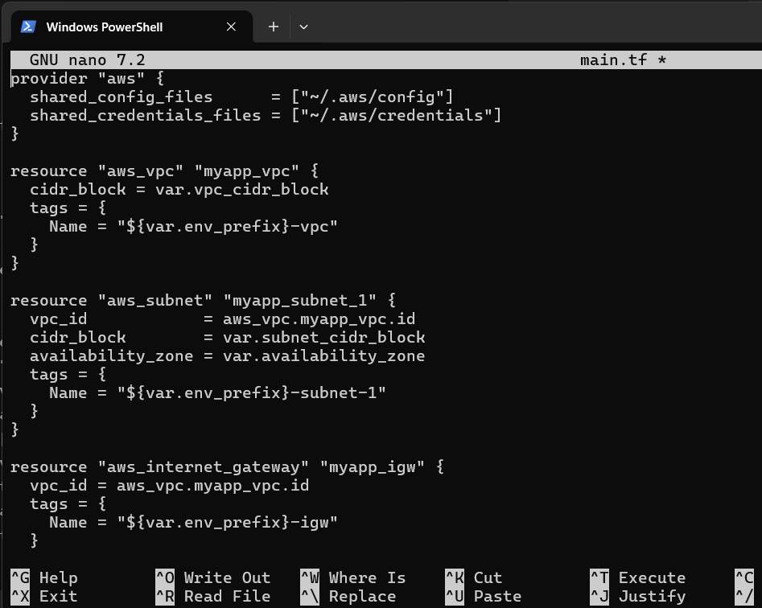

1. Create entry-script.sh with the following content:

#!/bin/bashset -e

yum update -y

yum install -y nginx

systemctl start nginx

systemctl enable nginx

Save screenshot as: task1_entry_script.png — content of entry-script.sh file.

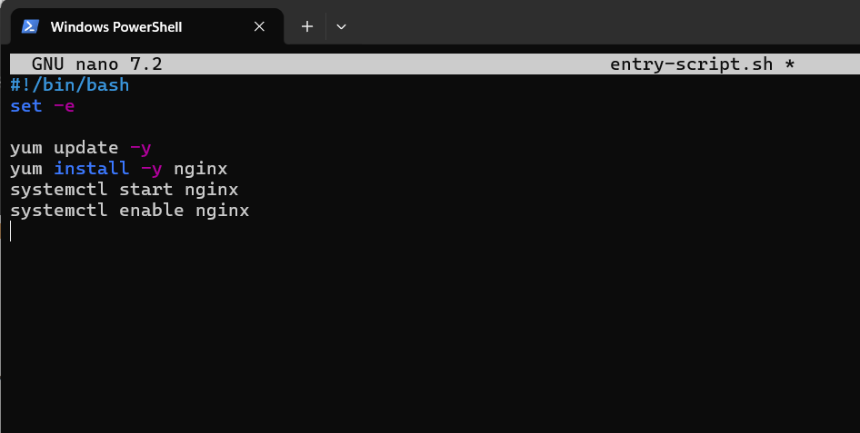

1. Generate SSH key pair if not already exists:

ssh-keygen -t ed25519 -f ~/.ssh/id_ed25519 -N ""

Save screenshot as: task1_ssh_keygen.png — terminal showing SSH key generation.

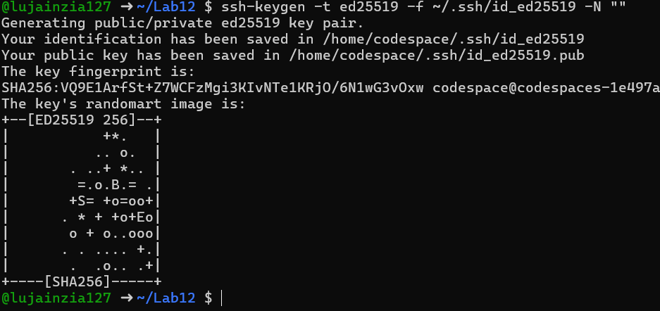

1. Initialize Terraform:

terraform init

Save screenshot as: task1_terraform_init.png — terraform init output.

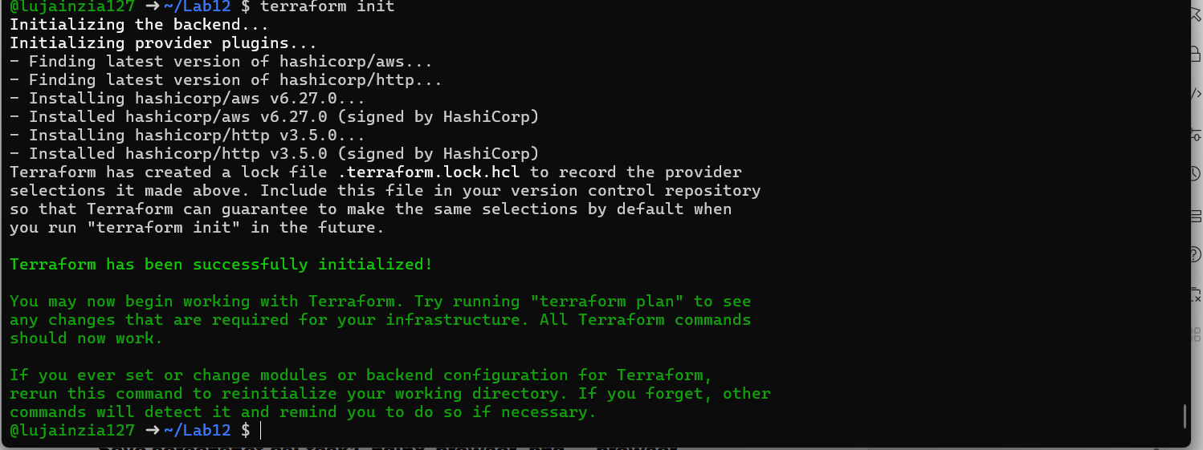

1. Apply the configuration:

terraform apply -auto-approve

Save screenshot as: task1_terraform_apply.png — terraform apply output showing resources created.

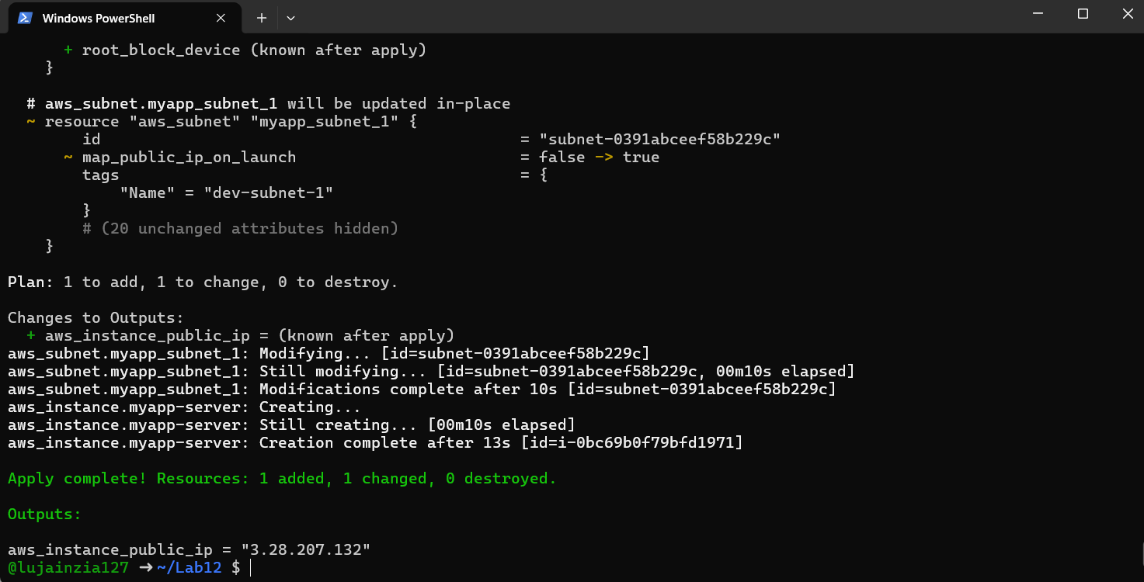

1. Display the output:

terraform output

Save screenshot as: task1_terraform_output.png — terraform output showing public IP.

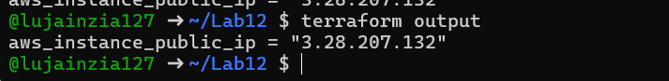

1. Test nginx in browser:

Open browser and navigate to http://<public-ip>

Save screenshot as: task1_nginx_browser. png — browser showing nginx default page.

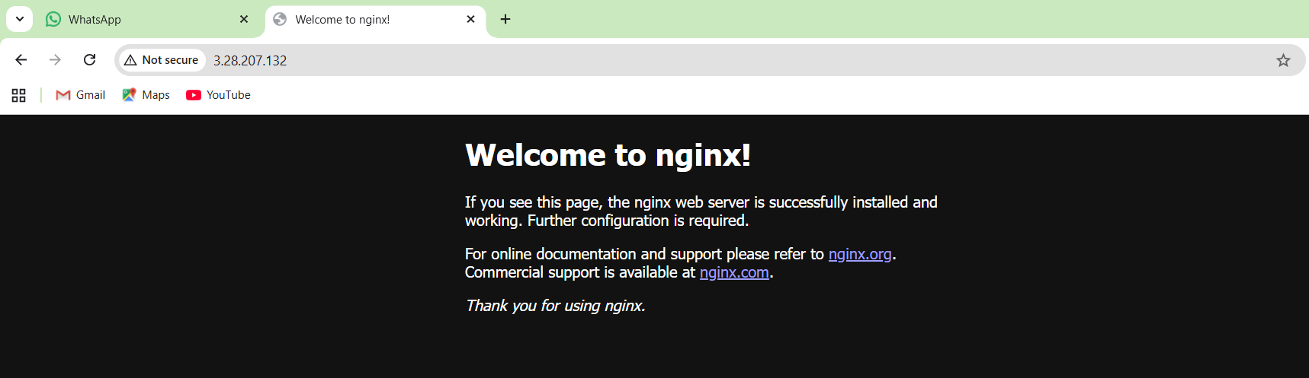

1. Destroy resources:

terraform destroy

Type yes when prompted for confirmation.

Save screenshot as: task1_terraform_destroy.png — terraform destroy output.

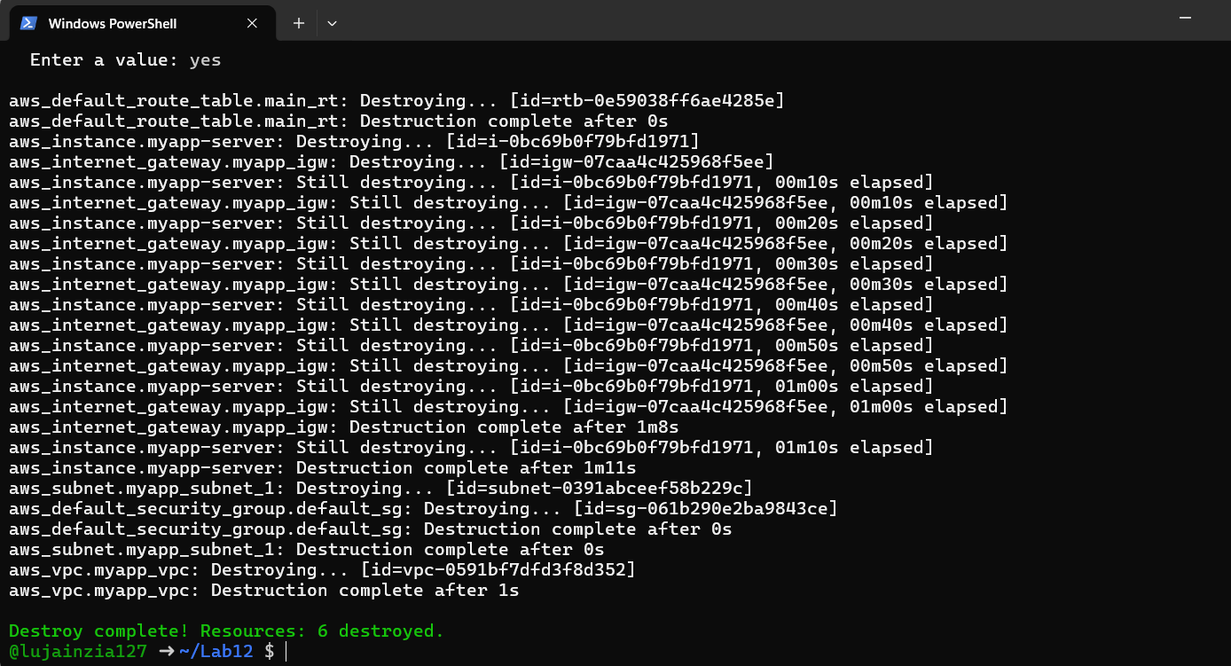

Task 2 — Use remote-exec provisioner

1. Modify the aws_instance resource in main.tf to use remote-exec provisioner:

Replace the user_data line with the following provisioner block:

resource "aws_instance" "myapp-server" {

ami = "ami-05524d6658fcf35b6"

instance_type = var.instance_type

subnet_id = aws_subnet.myapp_subnet_1.id

security_groups = [aws_default_security_group.default_sg.id]

availability_zone = var.availability_zone

associate_public_ip_address = true

key_name = aws_key_pair.ssh-key.key_name

connection {

type = "ssh"

user = "ec2-user"

private_key = file(var.private_key)

host = self.public_ip

}

provisioner "remote-exec" {

inline = [

"sudo yum update -y",

"sudo yum install -y nginx",

"sudo systemctl start nginx",

"sudo systemctl enable nginx"

]

}

tags = {

Name = "${var. env_prefix}-ec2-instance"

}

}

Save screenshot as: task2_main_tf_remote_exec.png — main.tf showing remote-exec provisioner.

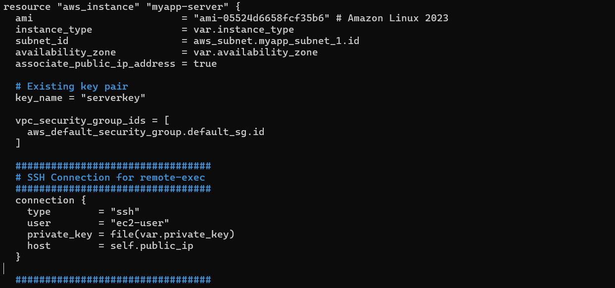

1. Apply the configuration:

terraform apply -auto-approve

Save screenshot as: task2_terraform_apply.png — terraform apply output showing remote-exec execution.

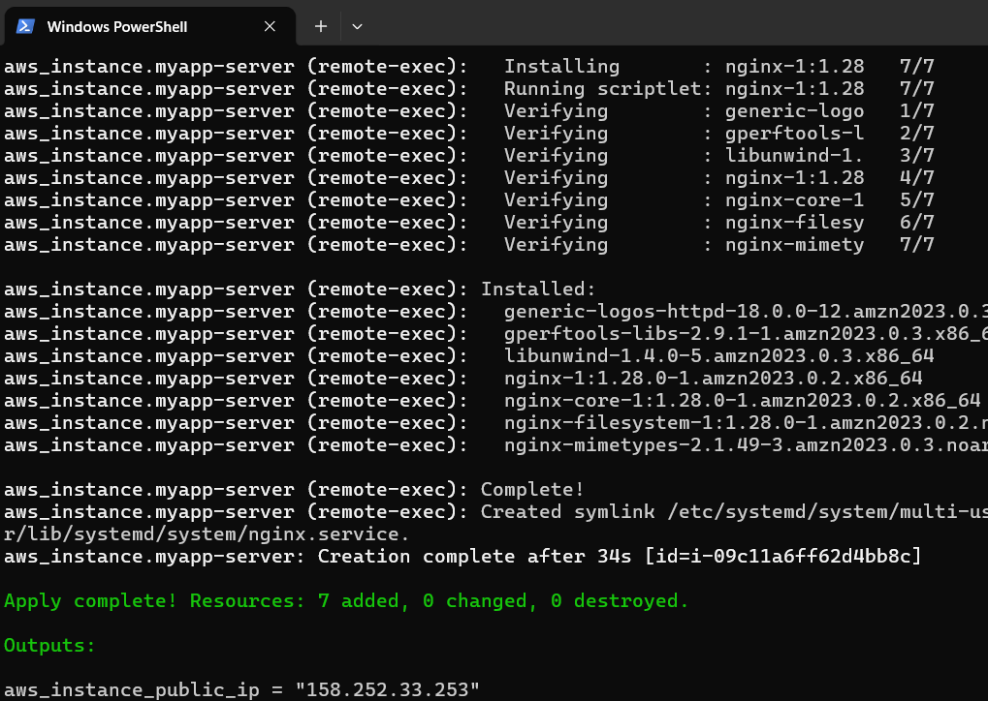

1. Display the output:

terraform output

Save screenshot as: task2_terraform_output.png — terraform output showing public IP.

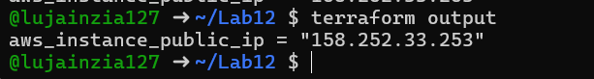

1. Test nginx in browser:

Open browser and navigate to http://<public-ip>

Save screenshot as: task2_nginx_browser.png — browser showing nginx default page.

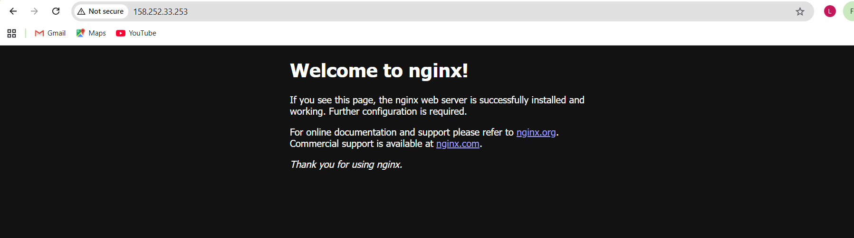

Task 3 — Use file and local-exec provisioners

1. Modify the aws_instance resource in main.tf to include all three provisioners:

resource "aws_instance" "myapp-server" {

ami = "ami-05524d6658fcf35b6"

instance_type = var.instance_type

subnet_id = aws_subnet.myapp_subnet_1.id

security_groups = [aws_default_security_group.default_sg.id]

availability_zone = var.availability_zone

associate_public_ip_address = true

key_name = aws_key_pair.ssh-key.key_name

connection {

type = "ssh"

user = "ec2-user"

private_key = file(var.private_key)

host = self.public_ip

}

provisioner "file" {

source = "./entry-script.sh"

destination = "/home/ec2-user/entry-script-on-ec2.sh"

}

provisioner "remote-exec" {

inline = [

"sudo chmod +x /home/ec2-user/entry-script-on-ec2.sh",

"sudo /home/ec2-user/entry-script-on-ec2.sh"

]

}

provisioner "local-exec" {

command = <<-EOF echo Instance ${self.id} with public IP ${self.public_ip} has been created EOF

}

tags = {

Name = "${var.env_prefix}-ec2-instance"

}

}

Save screenshot as: task3_main_tf_all_provisioners.png — main.tf showing file, remote-exec, and local-exec provisioners.

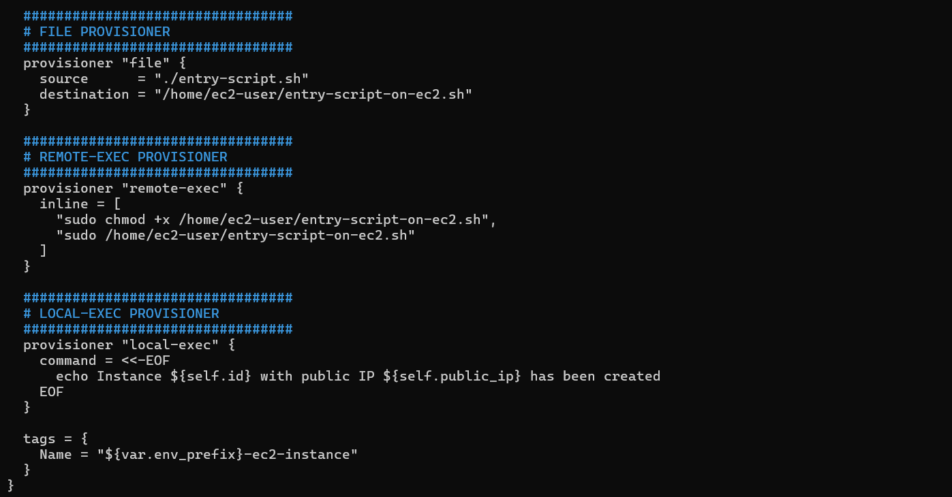

1. Apply the configuration:

terraform apply -auto-approve

Save screenshot as: task3_terraform_apply.png — terraform apply output showing all provisioners execution.

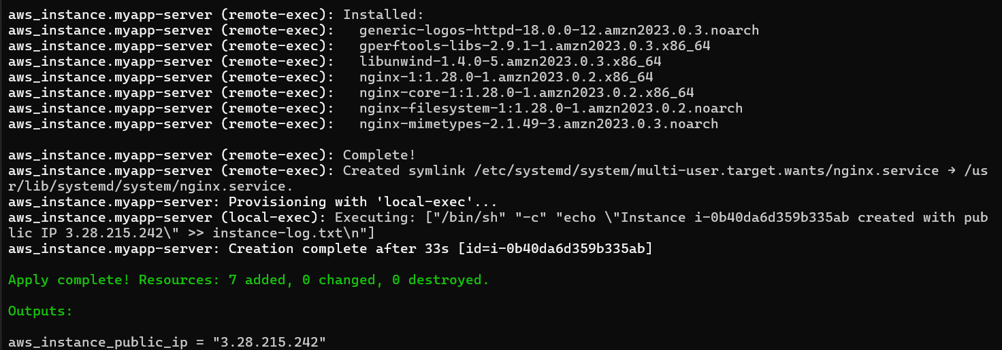

1. Display the output:

terraform output

Save screenshot as: task3_terraform_output.png — terraform output showing public IP.

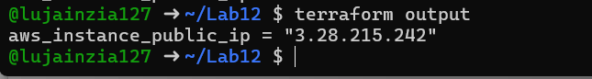

1. Test nginx in browser:

Open browser and navigate to http://<public-ip>

Save screenshot as: task3_nginx_browser.png — browser showing nginx default page.

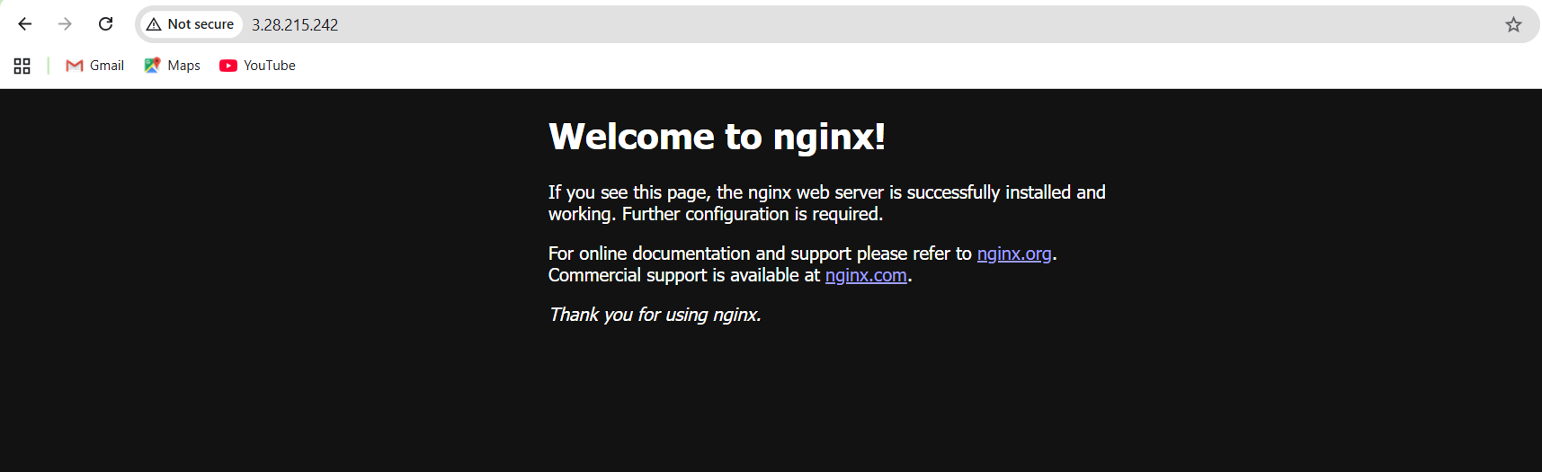

1. Destroy the resources:

terraform destroy

Type yes when prompted.

Save screenshot as: task3_terraform_destroy.png — terraform destroy output.

1. Remove the provisioners and restore user_data:

Replace the connection and provisioner blocks with:

user_data = file("./entry-script.sh")

Save screenshot as: task3_main_tf_restored.png — main.tf showing user_data restored.

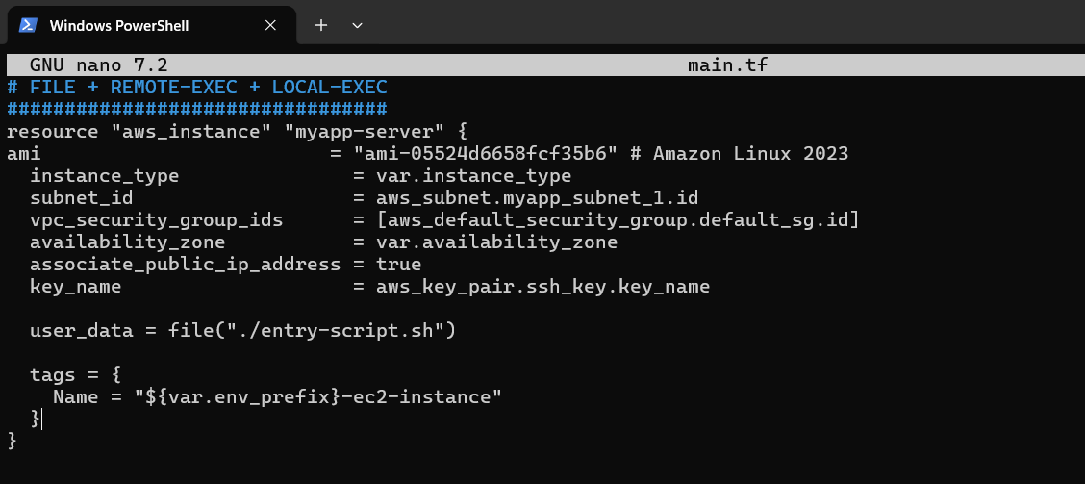

Task 4 — Create Terraform modules (subnet module)

1. Create the module directory structure:

mkdir -p modules/subnet

touch modules/subnet/main.tf

touch modules/subnet/variables.tf

touch modules/subnet/outputs. tf

Save screenshot as: task4_module_structure.png — terminal showing module directory structure (use tree or ls -R).

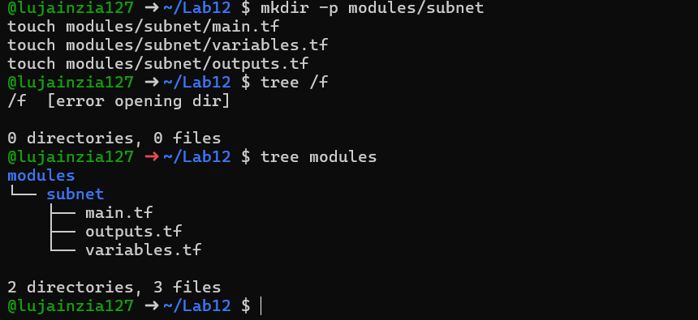

1. Create modules/subnet/variables.tf:

variable "vpc_id" {}variable "subnet_cidr_block" {}variable "availability_zone" {}variable "env_prefix" {}variable "default_route_table_id" {}

Save screenshot as: task4_subnet_variables.png — content of modules/subnet/variables.tf.

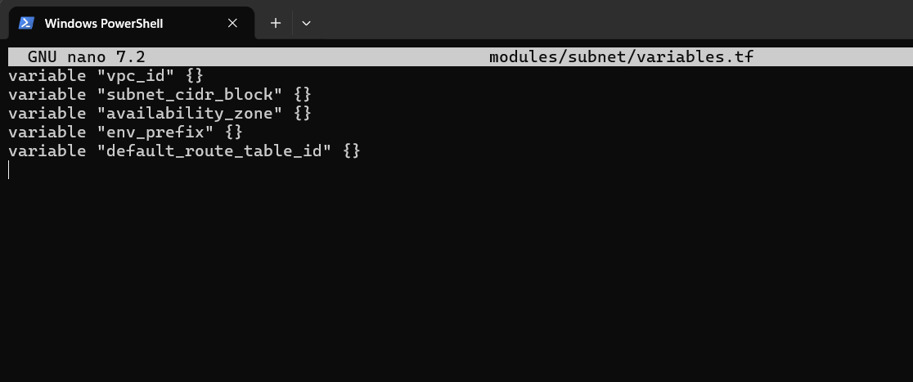

1. Create modules/subnet/main.tf:

resource "aws_subnet" "myapp_subnet_1" {

vpc_id = var.vpc_id

cidr_block = var.subnet_cidr_block

availability_zone = var.availability_zone

map_public_ip_on_launch = true

tags = {

Name = "${var.env_prefix}-subnet-1"

}

}

resource "aws_default_route_table" "main_rt" {

default_route_table_id = var.default_route_table_id

route {

cidr_block = "0.0.0.0/0"

gateway_id = aws_internet_gateway. myapp_igw.id

}

tags = {

Name = "${var.env_prefix}-rt"

}

}

resource "aws_internet_gateway" "myapp_igw" {

vpc_id = var.vpc_id

tags = {

Name = "${var.env_prefix}-igw"

}

}

Save screenshot as: task4_subnet_main.png — content of modules/subnet/main.tf.

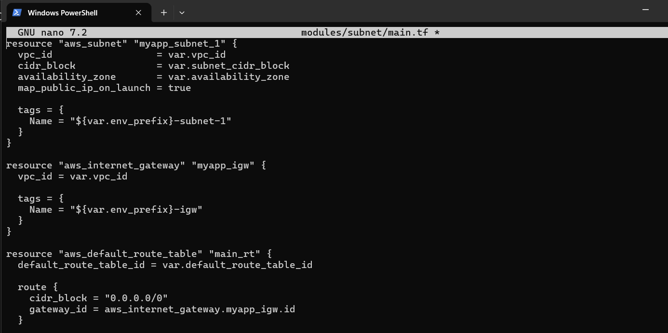

1. Create modules/subnet/outputs.tf:

output "subnet" {

value = aws_subnet.myapp_subnet_1

}

Save screenshot as: task4_subnet_outputs.png — content of modules/subnet/outputs.tf.

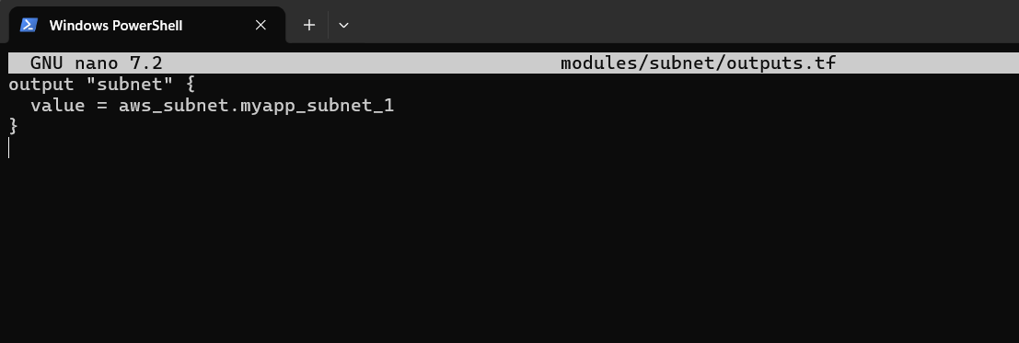

1. Modify the root main.tf to use the subnet module:

Remove the subnet, route table, and internet gateway resources and replace them with:

module "myapp-subnet" {

source = "./modules/subnet"

vpc_id = aws_vpc.myapp_vpc. id

subnet_cidr_block = var.subnet_cidr_block

availability_zone = var.availability_zone

env_prefix = var.env_prefix

default_route_table_id = aws_vpc.myapp_vpc.default_route_table_id

}

And update the instance resource to reference the module output:

resource "aws_instance" "myapp-server" {

# ... other settings ...

subnet_id = module.myapp-subnet. subnet.id

# ... rest of configuration ...

}

Save screenshot as: task4_main_tf_with_module.png — main.tf showing module usage.

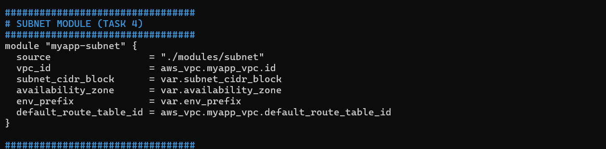

1. Initialize Terraform to download the module:

terraform init

Save screenshot as: task4_terraform_init.png — terraform init output showing module initialization.

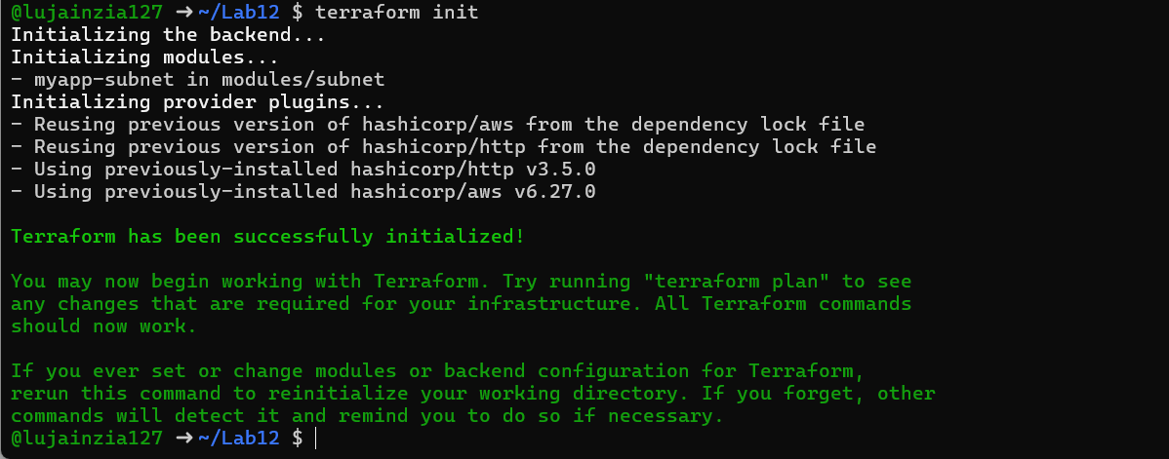

1. Apply the configuration:

terraform apply -auto-approve

Save screenshot as: task4_terraform_apply.png — terraform apply output with module.

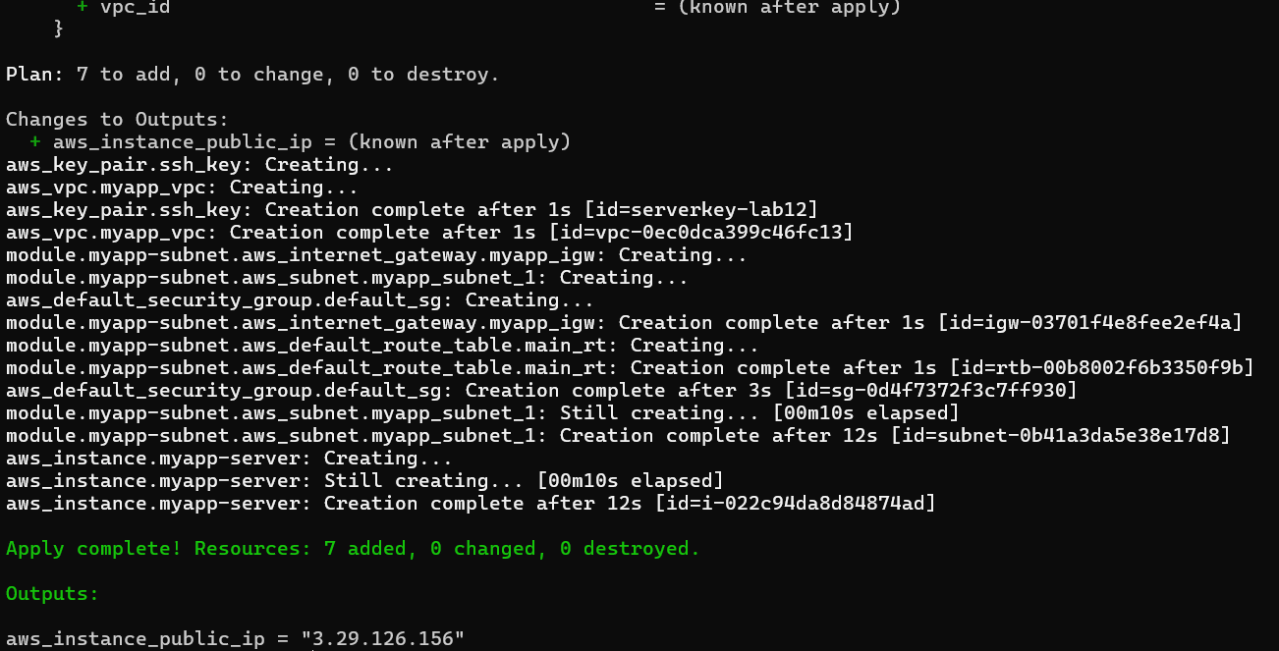

1. Display the output:

terraform output

Save screenshot as: task4_terraform_output.png — terraform output showing public IP.

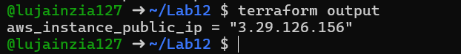

1. Test nginx in browser:

Open browser and navigate to http://<public-ip>

Save screenshot as: task4_nginx_browser.png — browser showing nginx default page.

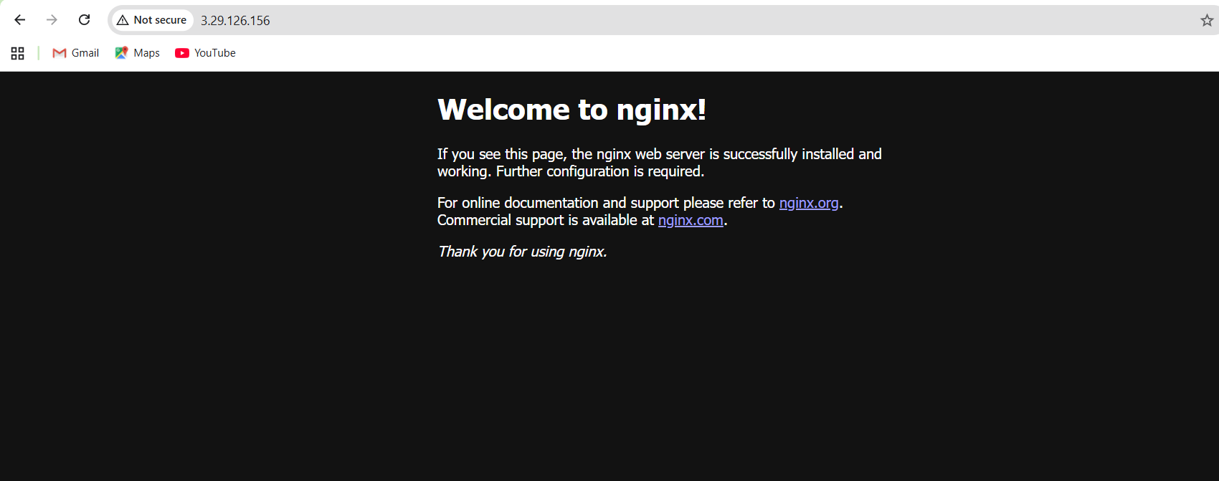

Task 5 — Create webserver module

1. Create the webserver module directory structure:

mkdir -p modules/webserver

touch modules/webserver/main.tf

touch modules/webserver/variables.tf

touch modules/webserver/outputs.tf

Save screenshot as: task5_webserver_module_structure.png — terminal showing webserver module directory.

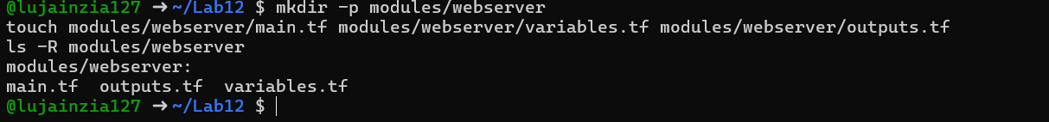

1. Create modules/webserver/variables.tf:

variable "env_prefix" {}variable "instance_type" {}variable "availability_zone" {}variable "public_key" {}variable "my_ip" {}variable "vpc_id" {}variable "subnet_id" {}variable "script_path" {}variable "instance_suffix" {}

Save screenshot as: task5_webserver_variables.png — content of modules/webserver/variables. tf.

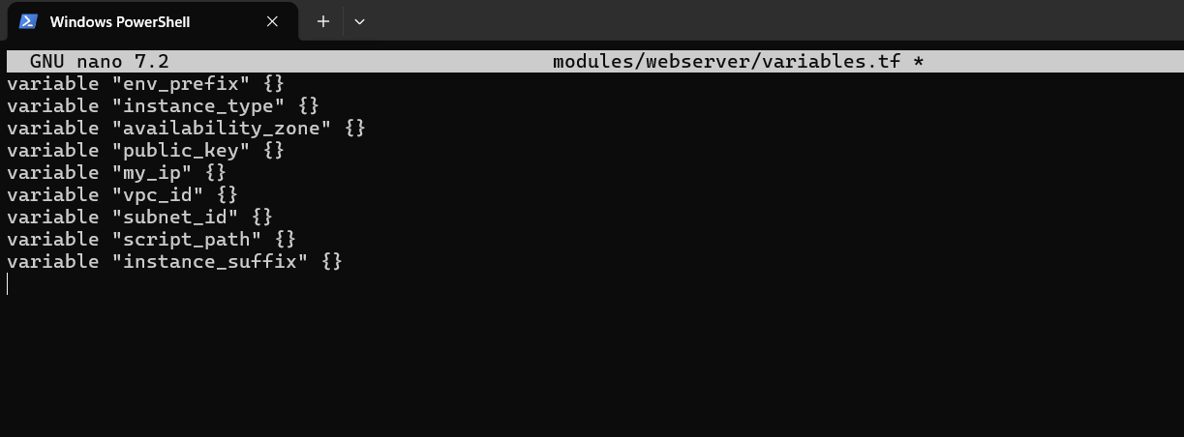

1. Create modules/webserver/main.tf:

resource "aws_security_group" "web_sg" {

vpc_id = var.vpc_id

name = "${var.env_prefix}-web-sg-${var.instance_suffix}"

description = "Security group for web server allowing HTTP, HTTPS and SSH"

ingress {

from_port = 22

to_port = 22

protocol = "tcp"

cidr_blocks = [var.my_ip]

}

ingress {

from_port = 443

to_port = 443

protocol = "tcp"

cidr_blocks = ["0.0.0.0/0"]

}

ingress {

from_port = 80

to_port = 80

protocol = "tcp"

cidr_blocks = ["0.0.0.0/0"]

}

egress {

from_port = 0

to_port = 0

protocol = "-1"

cidr_blocks = ["0.0.0.0/0"]

prefix_list_ids = []

}

tags = {

Name = "${var.env_prefix}-default-sg"

}

}

resource "aws_key_pair" "ssh-key" {

key_name = "${var.env_prefix}-serverkey-${var.instance_suffix}"

public_key = file(var.public_key)

}

resource "aws_instance" "myapp-server" {

ami = "ami-05524d6658fcf35b6" # Amazon Linux 2023 Kernel 6.1 AMI

instance_type = var. instance_type

subnet_id = var.subnet_id

security_groups = [aws_security_group.web_sg.id]

availability_zone = var. availability_zone

associate_public_ip_address = true

key_name = aws_key_pair.ssh-key.key_name

user_data = file(var.script_path)

tags = {

Name = "${var.env_prefix}-ec2-instance-${var.instance_suffix}"

}

}

Save screenshot as: task5_webserver_main.png — content of modules/webserver/main.tf.

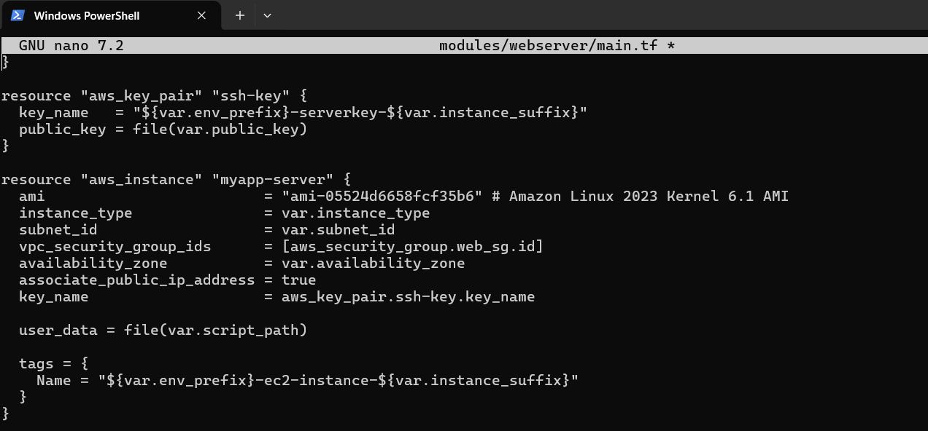

1. Create modules/webserver/outputs.tf:

output "aws_instance" {

value = aws_instance.myapp-server

}

Save screenshot as: task5_webserver_outputs.png — content of modules/webserver/outputs.tf.

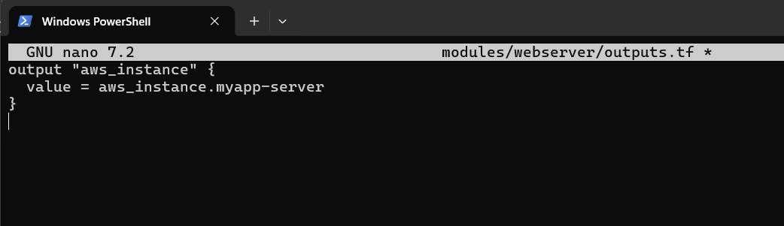

1. Modify the root main.tf:

Remove the security group, key pair, and instance resources. Replace them with:

module "myapp-webserver" {

source = "./modules/webserver"

env_prefix = var.env_prefix

instance_type = var. instance_type

availability_zone = var.availability_zone

public_key = var.public_key

my_ip = local.my_ip

vpc_id = aws_vpc.myapp_vpc.id

subnet_id = module.myapp-subnet.subnet.id

script_path = "./entry-script.sh"

instance_suffix = "0"

}

Save screenshot as: task5_main_tf_webserver_module.png — main.tf showing webserver module usage.

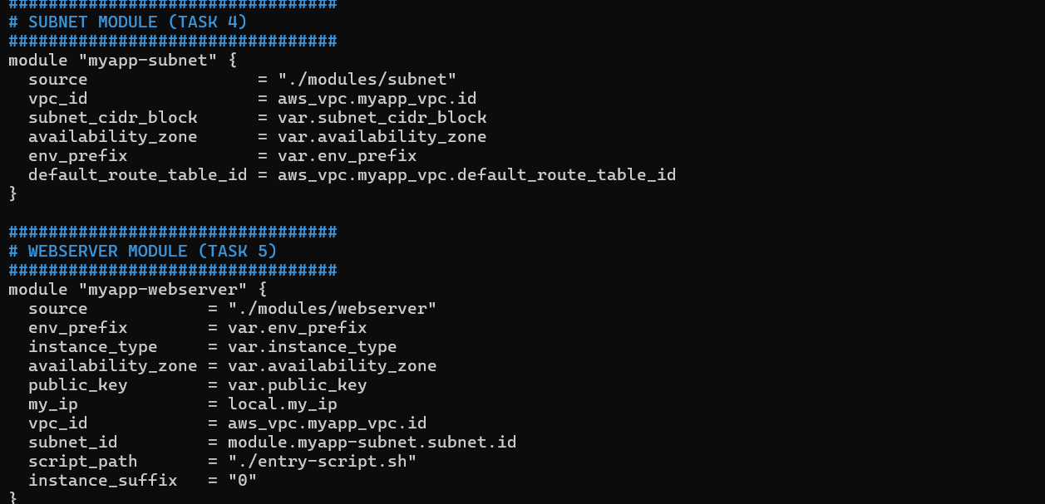

1. Update outputs.tf:

output "webserver_public_ip" {

value = module.myapp-webserver.aws_instance.public_ip

}

Save screenshot as: task5_outputs_updated.png — updated outputs.tf.

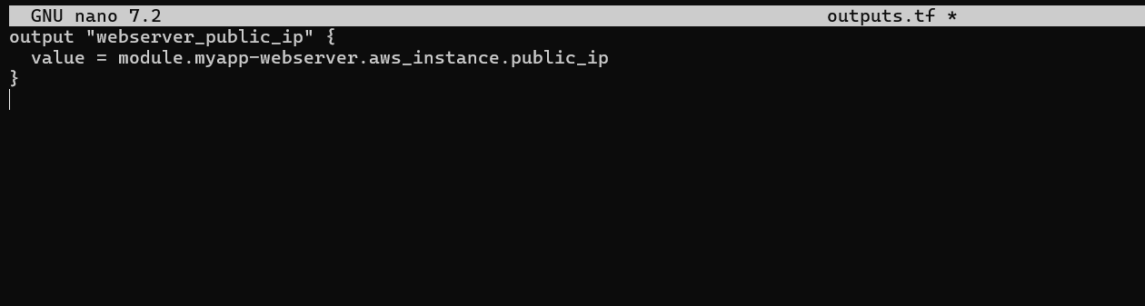

1. Initialize Terraform:

terraform init

Save screenshot as: task5_terraform_init.png — terraform init output.

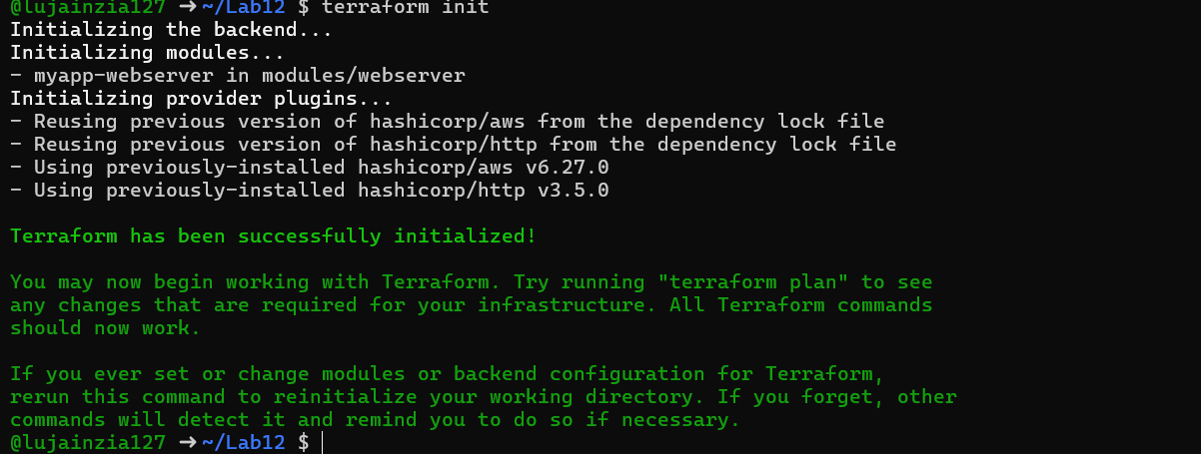

1. Apply the configuration:

terraform apply -auto-approve

Save screenshot as: task5_terraform_apply.png — terraform apply output with webserver module.

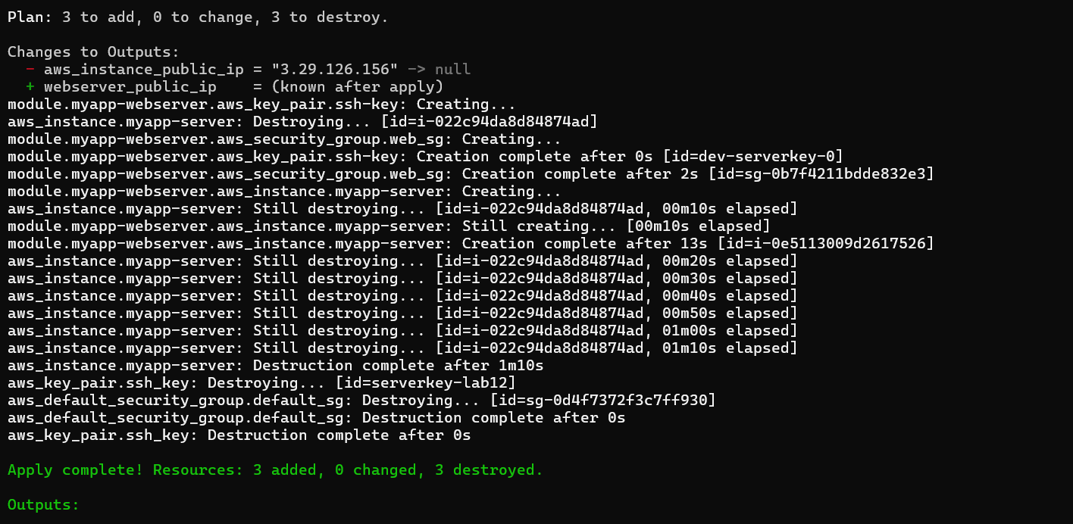

1. Display the output:

terraform output

Save screenshot as: task5_terraform_output.png — terraform output showing webserver public IP.

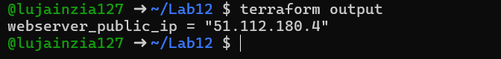

1. Test nginx in browser:

Open browser and navigate to http://<public-ip>

Save screenshot as: task5_nginx_browser.png — browser showing nginx default page.

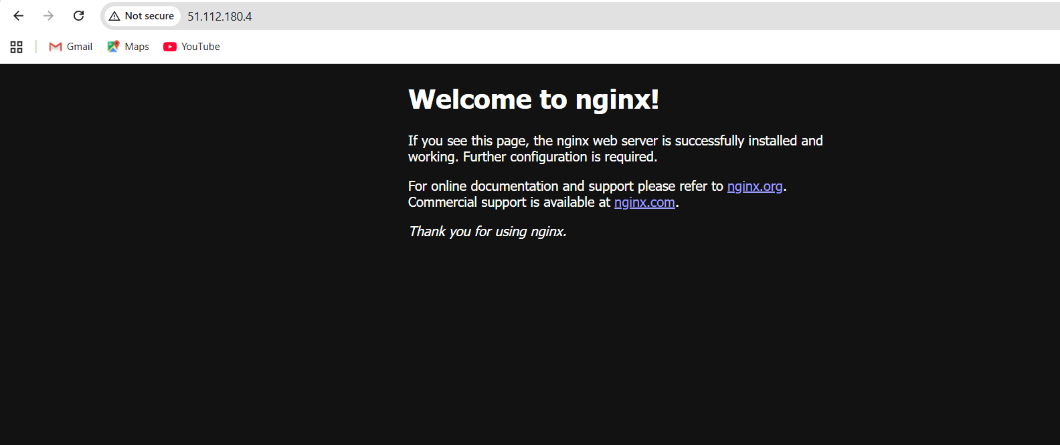

1. Destroy resources:

terraform destroy

Type yes when prompted.

Save screenshot as: task5_terraform_destroy.png — terraform destroy output.

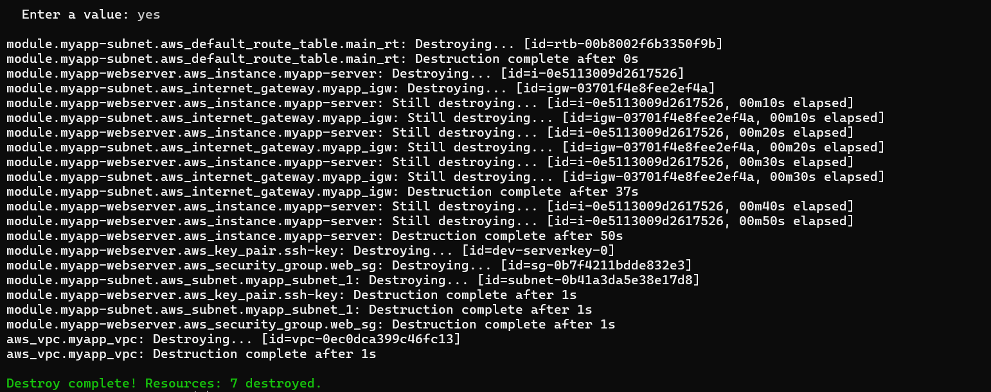

Task 6 — Configure HTTPS with self-signed certificates

1. Update entry-script.sh with SSL configuration:

#!/bin/bashset -e

yum update -y

yum install -y nginx

systemctl start nginx

systemctl enable nginx

# Create directories for SSL certificates if they don't exist

mkdir -p /etc/ssl/private

mkdir -p /etc/ssl/certs

# Get IMDSv2 token

TOKEN=$(curl -s -X PUT "http://169.254.169.254/latest/api/token" \ -H "X-aws-ec2-metadata-token-ttl-seconds: 21600")

# Get current public IP

PUBLIC_IP=$(curl -s -H "X-aws-ec2-metadata-token: $TOKEN" \ http://169.254.169.254/latest/meta-data/public-ipv4)

PUBLIC_HOSTNAME=$(curl -s -H "X-aws-ec2-metadata-token: $TOKEN" \ http://169.254.169.254/latest/meta-data/public-hostname)

# Generate self-signed certificate with dynamic IP

openssl req -x509 -nodes -days 365 -newkey rsa:2048 \

-keyout /etc/ssl/private/selfsigned.key \

-out /etc/ssl/certs/selfsigned.crt \

-subj "/CN=$PUBLIC_IP" \

-addext "subjectAltName=IP:$PUBLIC_IP" \

-addext "basicConstraints=CA:FALSE" \

-addext "keyUsage=digitalSignature,keyEncipherment" \

-addext "extendedKeyUsage=serverAuth"

echo "Self-signed certificate created for IP: $PUBLIC_IP"

# Backup existing nginx. conf

cp /etc/nginx/nginx.conf /etc/nginx/nginx.conf.bak

# Overwrite nginx.conf with the desired content

cat <<EOF > /etc/nginx/nginx.confuser nginx;worker_processes auto;error_log /var/log/nginx/error.log notice;pid /run/nginx. pid;events { worker_connections 1024;}http { log_format main '\$remote_addr - \$remote_user [\$time_local] "\$request" ' '\$status \$body_bytes_sent "\$http_referer" ' '"\$http_user_agent" "\$http_x_forwarded_for"'; access_log /var/log/nginx/access.log main; sendfile on; tcp_nopush on; keepalive_timeout 65; types_hash_max_size 4096; include /etc/nginx/mime.types; default_type application/octet-stream; upstream backend_servers { server 158.252.94.241:80; server 158.252.94.242:80 backup; } server { listen 443 ssl; server_name $PUBLIC_IP; ssl_certificate /etc/ssl/certs/selfsigned. crt; ssl_certificate_key /etc/ssl/private/selfsigned.key; location / { root /usr/share/nginx/html; index index.html; # proxy_pass http://158.252.94.241:80; # proxy_pass http://backend_servers; } } server { listen 80; server_name _; return 301 https://\$host\$request_uri; }}EOF

# Test and restart Nginx

systemctl restart nginx

Save screenshot as: task6_entry_script_https.png — updated entry-script.sh with HTTPS configuration.

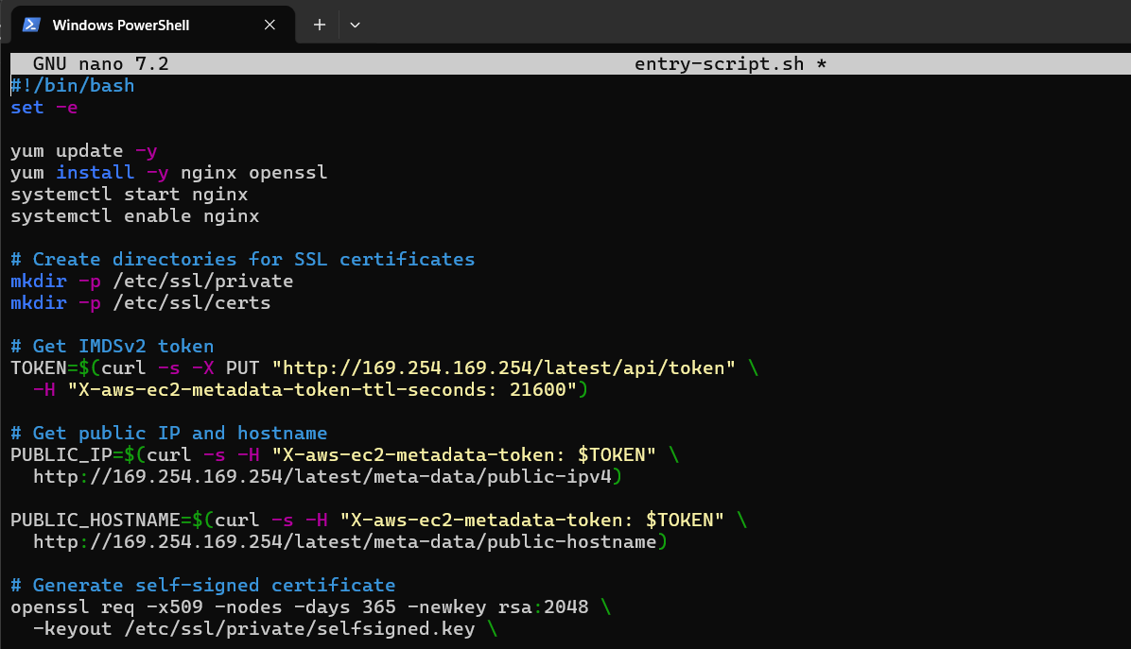

1. Apply the configuration:

terraform apply -auto-approve

Save screenshot as: task6_terraform_apply.png — terraform apply output.

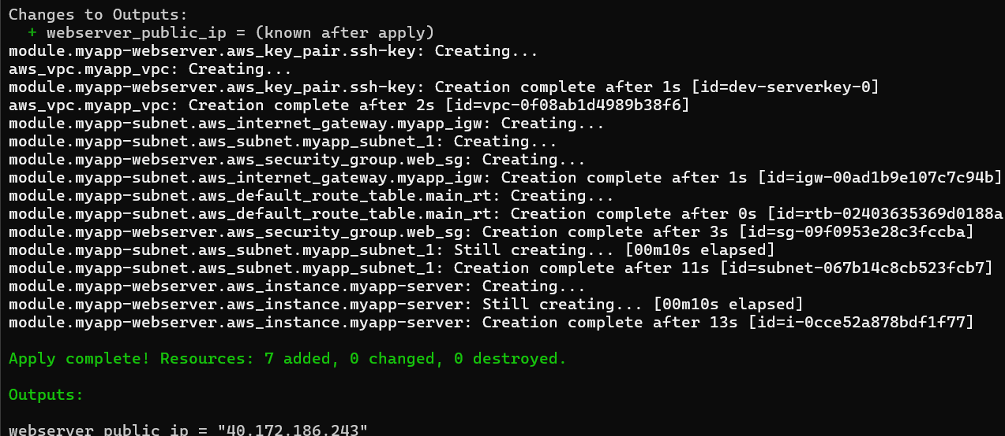

1. Display the output:

terraform output

Save screenshot as: task6_terraform_output.png — terraform output showing public IP.

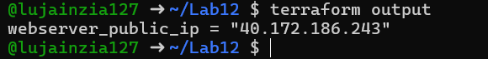

1. Test HTTPS in browser:

Open browser and navigate to https://<public-ip>

You will see a warning: "Warning: Potential Security Risk Ahead"

Click "Advanced" button

Click "Accept the Risk and Continue"

Save screenshot as: task6_browser_security_warning.png — browser showing security warning.

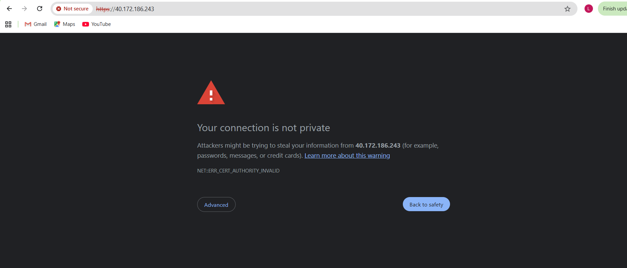

Save screenshot as: task6_nginx_https_browser.png — browser showing nginx page over HTTPS after accepting risk.

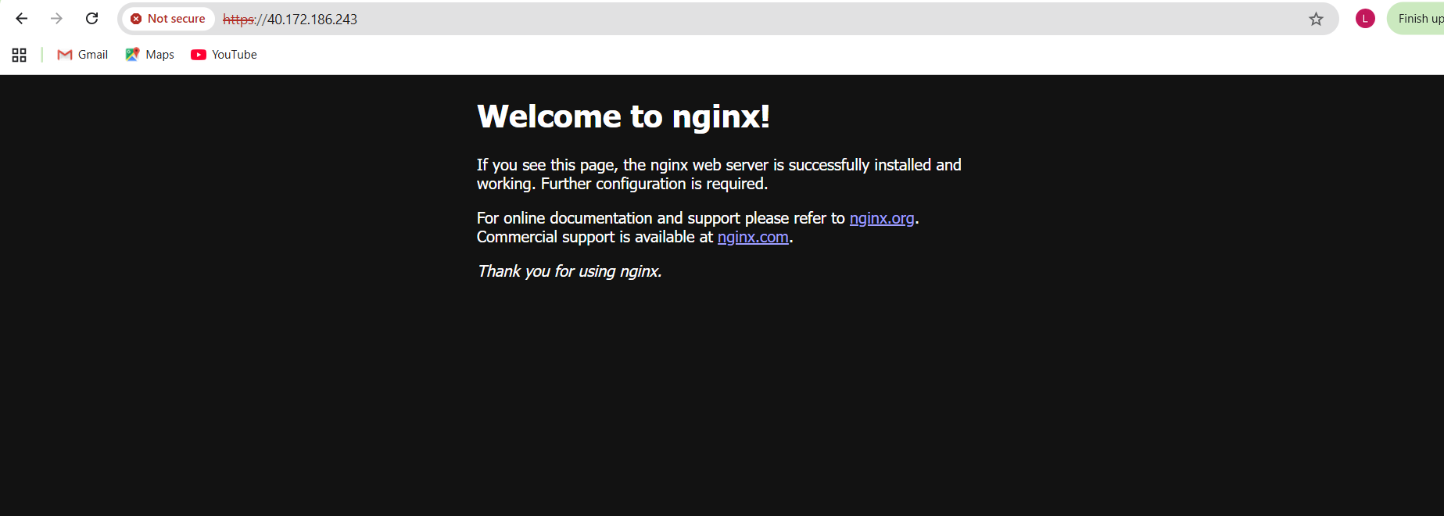

1. Verify HTTP to HTTPS redirect:

Open browser and navigate to http://<public-ip>

Verify it redirects to https://<public-ip>

Save screenshot as: task6_http_redirect.png — browser showing redirect from HTTP to HTTPS.

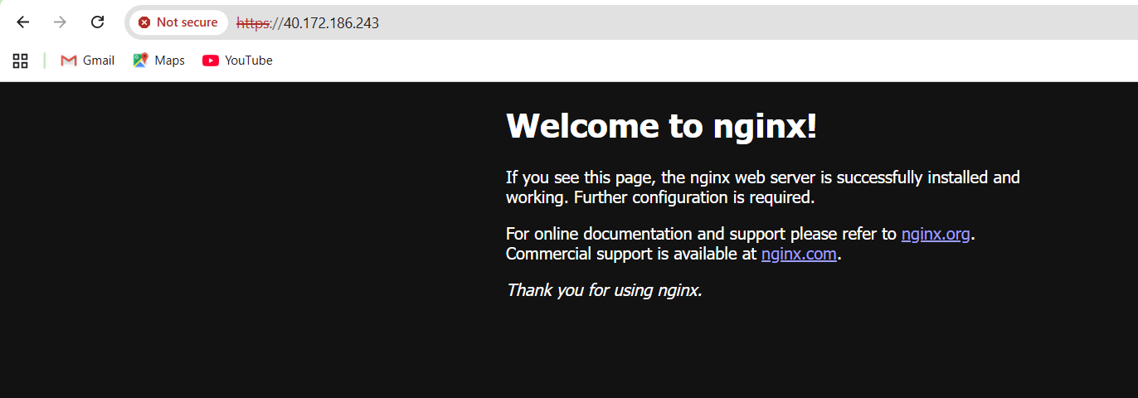

Task 7 — Configure Nginx as reverse proxy

1. Create apache.sh script for backend web server:

#!/bin/bash

yum update -y

yum install httpd -y

systemctl start httpd

systemctl enable httpdecho "<h1>Welcome to My Web Server</h1>" > /var/www/html/index.html

hostnamectl set-hostname myapp-webserverecho "<h2>Hostname: $(hostname)</h2>" >> /var/www/html/index.html

TOKEN=$(curl -s -X PUT "http://169.254.169.254/latest/api/token" \ -H "X-aws-ec2-metadata-token-ttl-seconds: 21600") echo "<h2>Private IP: $(curl -s -H "X-aws-ec2-metadata-token: $TOKEN" http://169.254.169.254/latest/meta-data/local-ipv4)</h2>" >> /var/www/html/index.htmlecho "<h2>Public IP: $(curl -s -H "X-aws-ec2-metadata-token: $TOKEN" http://169.254.169.254/latest/meta-data/public-ipv4)</h2>" >> /var/www/html/index.htmlecho "<h2>Public DNS: $(curl -s -H "X-aws-ec2-metadata-token: $TOKEN" http://169.254.169.254/latest/meta-data/public-hostname)</h2>" >> /var/www/html/index.htmlecho "<h2>Deployed via Terraform</h2>" >> /var/www/html/index. html

Save screenshot as: task7_apache_script.png — content of apache.sh file.

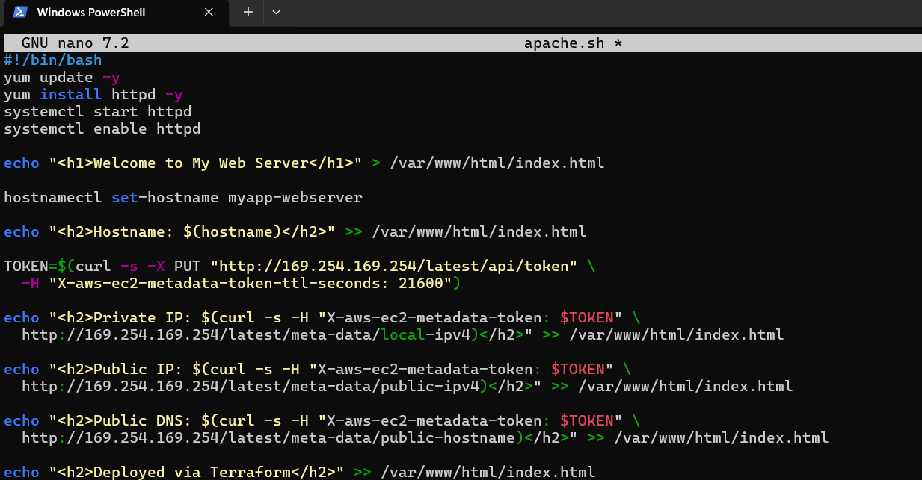

1. Add the backend web server module to main.tf:

module "myapp-web-1" {

source = "./modules/webserver"

env_prefix = var.env_prefix

instance_type = var.instance_type

availability_zone = var.availability_zone

public_key = var. public_key

my_ip = local.my_ip

vpc_id = aws_vpc. myapp_vpc.id

subnet_id = module.myapp-subnet.subnet. id

script_path = "./apache.sh"

instance_suffix = "1"

}

Save screenshot as: task7_main_tf_web1.png — main. tf showing myapp-web-1 module.

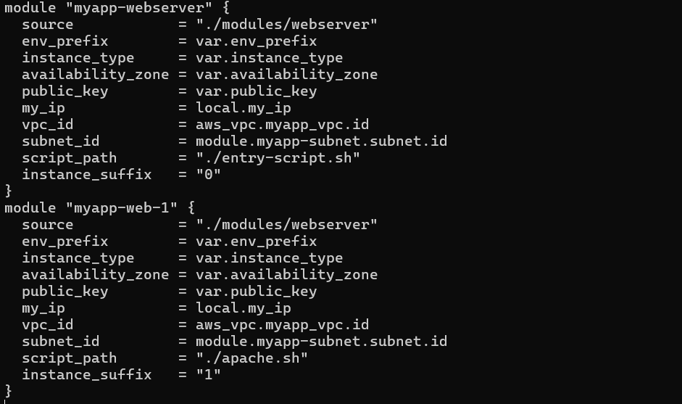

1. Update outputs.tf:

output "aws_web-1_public_ip" {

value = module.myapp-web-1.aws_instance.public_ip

}

Save screenshot as: task7_outputs_web1.png — outputs.tf with web-1 output.

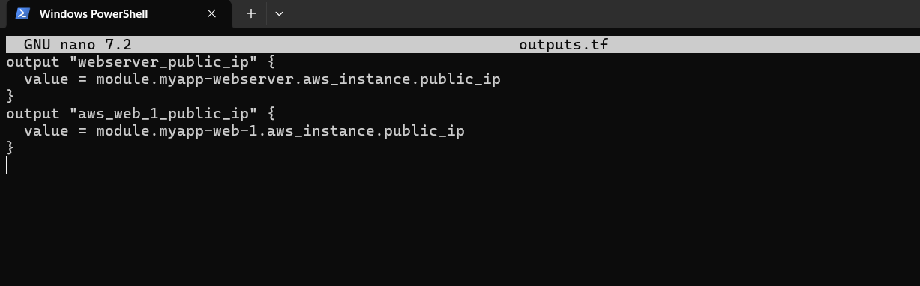

1. Apply the configuration:

terraform apply -auto-approve

Save screenshot as: task7_terraform_apply.png — terraform apply output showing both instances created.

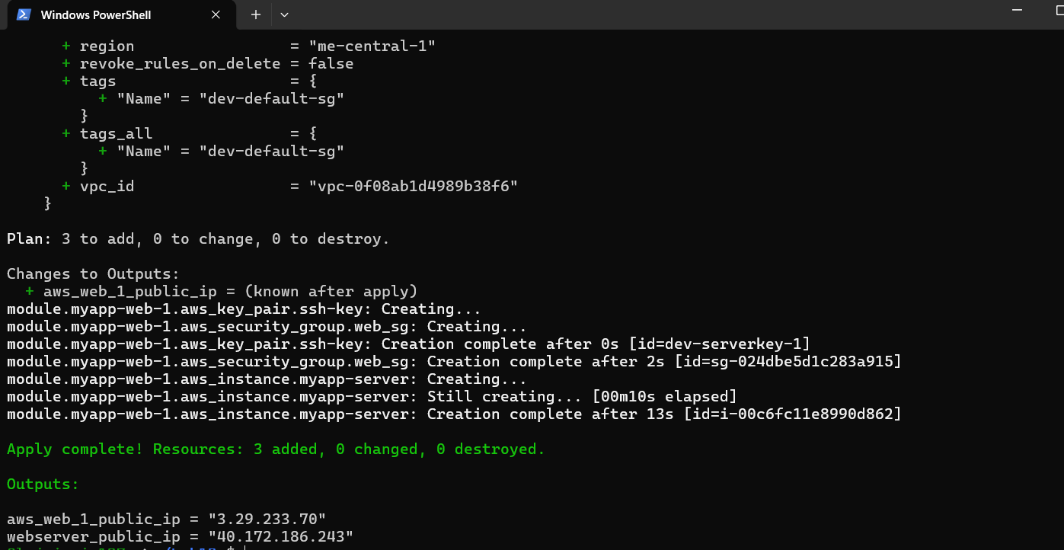

1. Get the outputs:

terraform output

Save screenshot as: task7_terraform_output.png — showing both public IPs.

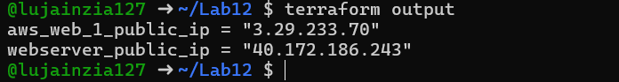

1. SSH into the webserver (Nginx proxy server):

ssh ec2-user@<webserver-public-ip>

Save screenshot as: task7_ssh_webserver. png — SSH session to webserver.

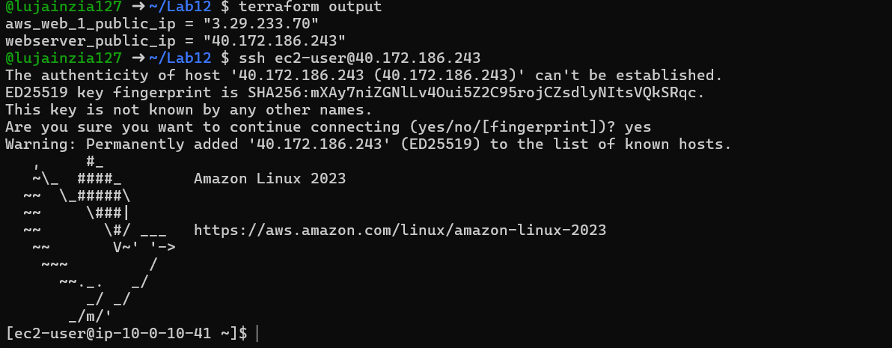

1. Edit the Nginx configuration:

sudo vim /etc/nginx/nginx.conf

Modify the location block to proxy to web-1:

location / { # root /usr/share/nginx/html; # index index. html;

proxy_pass http://<web-1-public-ip>:80; # proxy_pass http://backend_servers;

}

Save screenshot as: task7_nginx_conf_reverse_proxy.png — nginx.conf showing proxy_pass configuration.

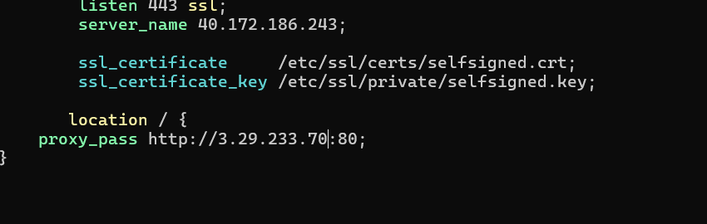

1. Restart Nginx:

sudo systemctl restart nginx

Save screenshot as: task7_nginx_restart.png — terminal showing nginx restart command.



1. View Nginx logs and configuration files:

cat /var/log/nginx/error.log

Save screenshot as: task7_error_log.png — content of error. log.

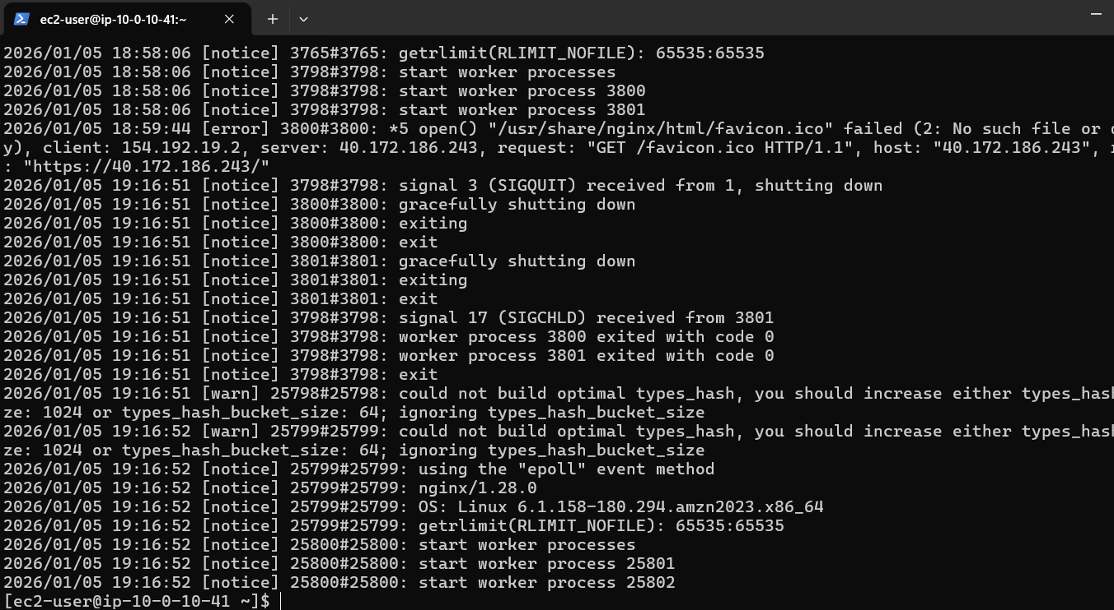

cat /var/log/nginx/access.log

Save screenshot as: task7_access_log.png — content of access.log.

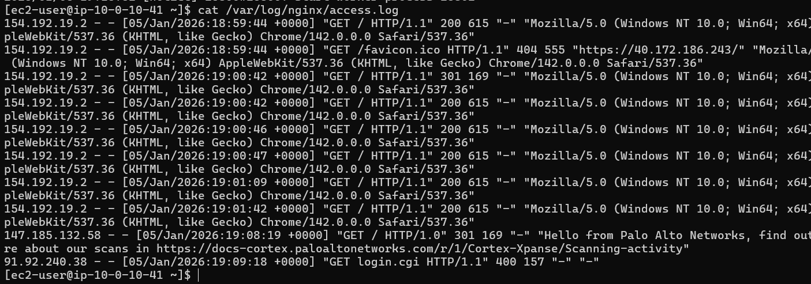

cat /etc/nginx/mime.types

Save screenshot as: task7_mime_types.png — content of mime.types.

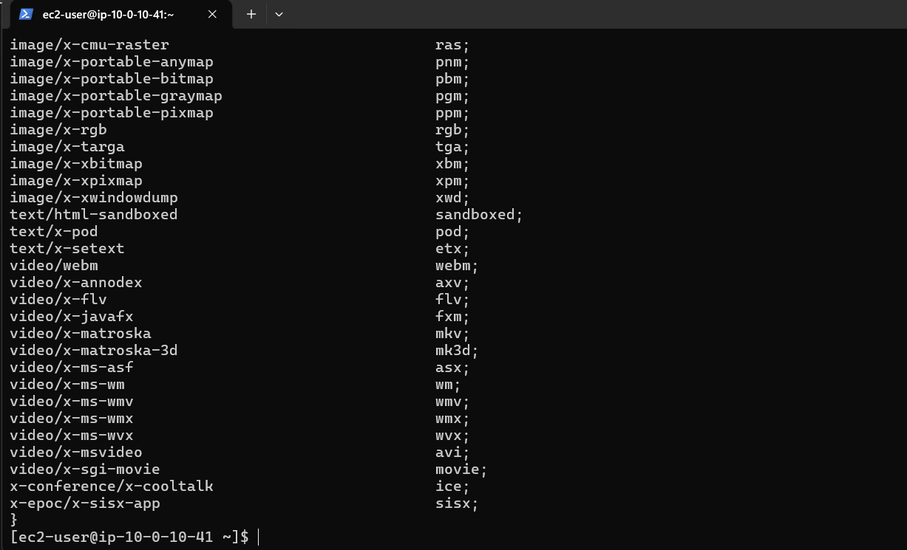

cat /etc/ssl/certs/selfsigned. crt

Save screenshot as: task7_ssl_cert.png — content of selfsigned.crt.

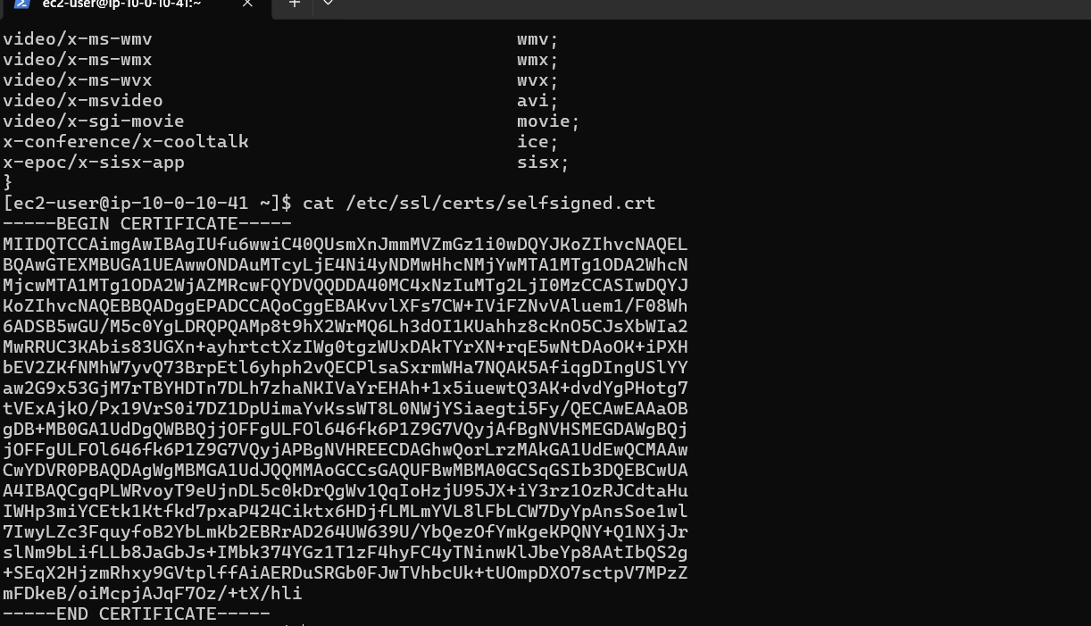

cat /etc/ssl/private/selfsigned.key

Save screenshot as: task7_ssl_key.png — content of selfsigned.key.

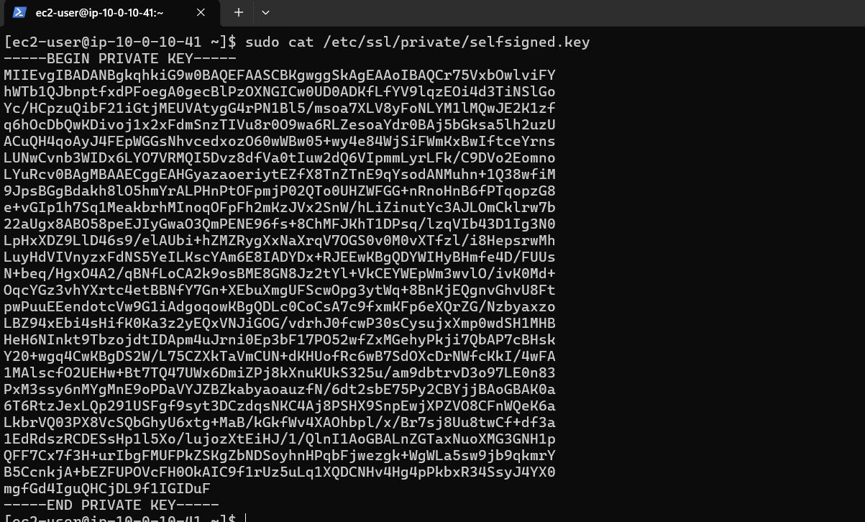

1. Test reverse proxy in browser:

Open browser and navigate to https://<webserver-public-ip>

You should see the web-1 Apache page through the Nginx proxy

Save screenshot as: task7_reverse_proxy_browser.png — browser showing web-1 content through proxy.

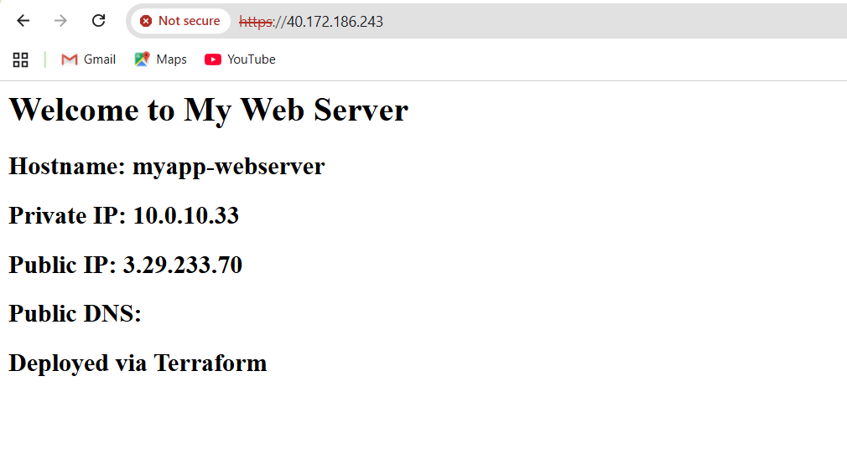

Task 8 — Configure Nginx as load balancer

1. Add the second web server module to main.tf:

module "myapp-web-2" {

source = "./modules/webserver"

env_prefix = var.env_prefix

instance_type = var.instance_type

availability_zone = var. availability_zone

public_key = var.public_key

my_ip = local.my_ip

vpc_id = aws_vpc.myapp_vpc. id

subnet_id = module.myapp-subnet.subnet. id

script_path = "./apache.sh"

instance_suffix = "2"

}

Save screenshot as: task8_main_tf_web2.png — main.tf showing myapp-web-2 module.

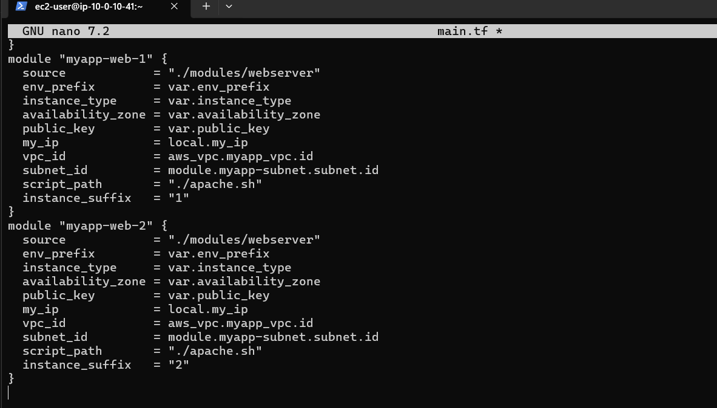

1. Update outputs.tf:

output "aws_web-2_public_ip" {

value = module. myapp-web-2.aws_instance.public_ip

}

Save screenshot as: task8_outputs_web2.png — outputs.tf with web-2 output.

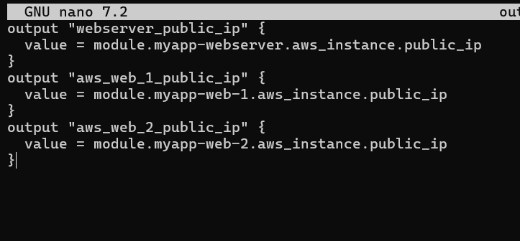

1. Apply the configuration:

terraform apply -auto-approve

Save screenshot as: task8_terraform_apply.png — terraform apply output showing web-2 created.

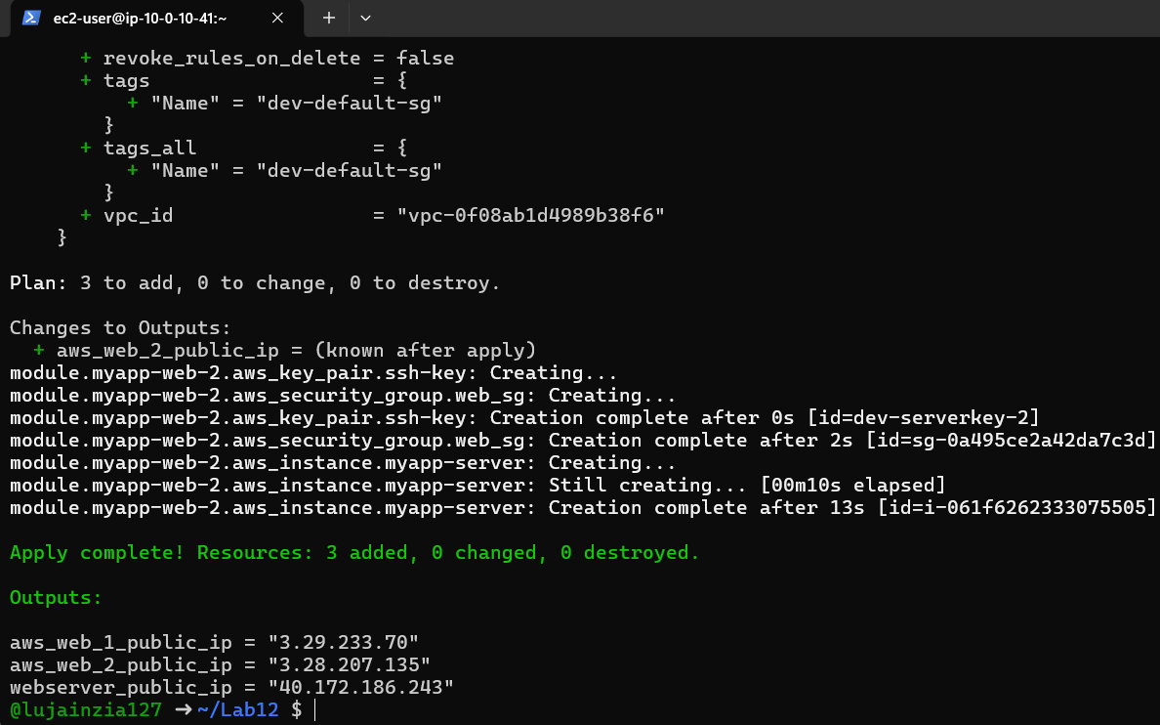

1. Get all outputs:

terraform output

Save screenshot as: task8_terraform_output.png — showing all three public IPs.

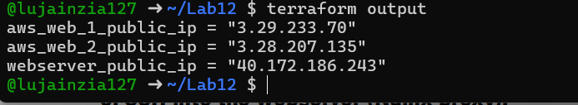

1. SSH into the webserver (Nginx proxy):

ssh ec2-user@<webserver-public-ip>

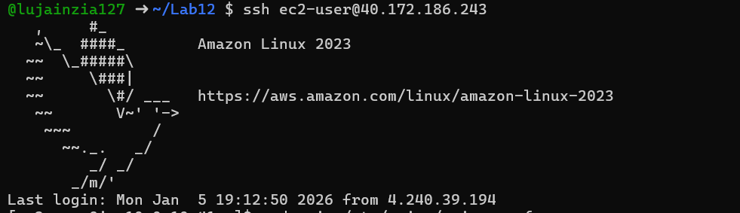

1. Edit Nginx configuration for load balancing:

sudo vim /etc/nginx/nginx.conf

Update the upstream block and location:

upstream backend_servers {

server <web-1-public-ip>:80;

server <web-2-public-ip>: 80;

}

# ... in server block:

location / { # root /usr/share/nginx/html; # index index.html; # proxy_pass http://<web-1-public-ip>:80;

proxy_pass http://backend_servers;

}

Save screenshot as: task8_nginx_conf_load_balancer.png — nginx.conf showing load balancing configuration.

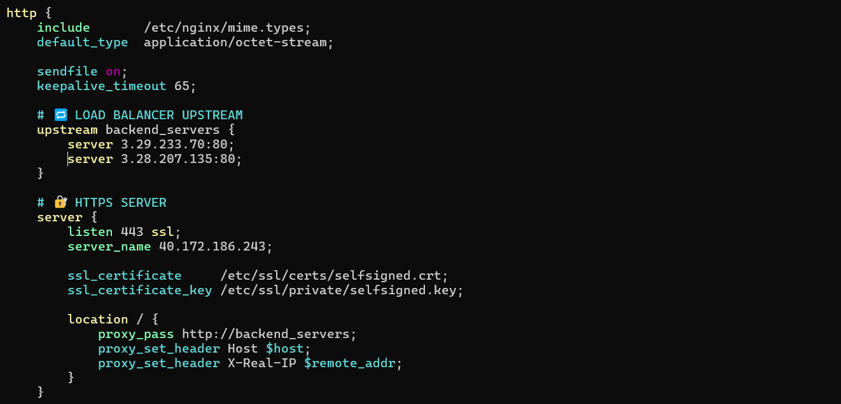

1. Restart Nginx:

sudo systemctl restart nginx

Save screenshot as: task8_nginx_restart.png — terminal showing nginx restart.

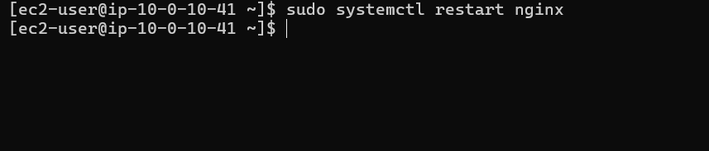

1. Test load balancing in browser:

Open browser and navigate to https://<webserver-public-ip>

Reload the page multiple times

You should see the content alternating between web-1 and web-2 (check the hostname/IP in the page)

Save screenshot as: task8_load_balancer_web1. png — browser showing web-1 content.

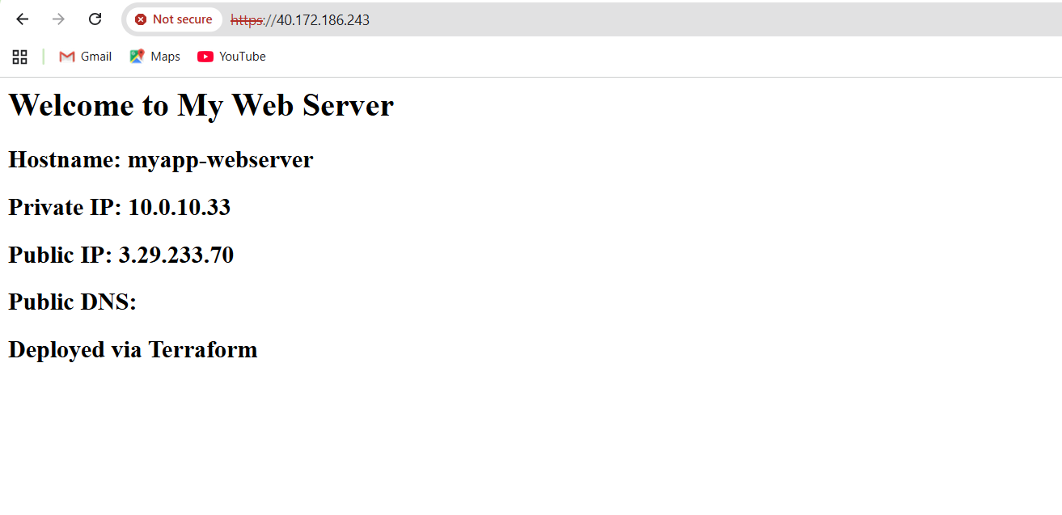

Save screenshot as: task8_load_balancer_web2.png — browser showing web-2 content after reload.

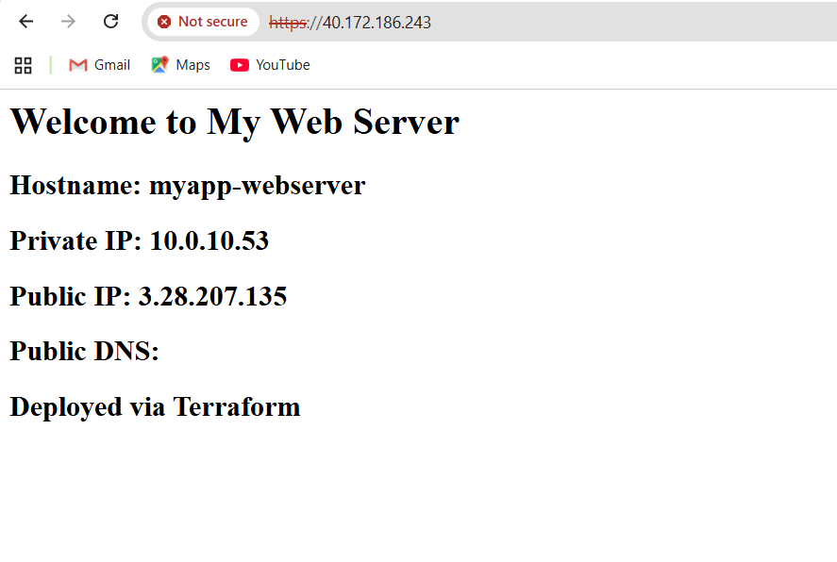

Task 9 — Configure high availability with backup servers

1. SSH into the webserver:

ssh ec2-user@<webserver-public-ip>

Edit Nginx configuration for high availability:

sudo vim /etc/nginx/nginx.conf

Update the upstream block to make web-2 a backup:

upstream backend_servers {

server <web-1-public-ip>:80;

server <web-2-public-ip>:80 backup;

}

Save screenshot as: task9_nginx_conf_ha_web1_primary.png — nginx.conf with web-2 as backup.

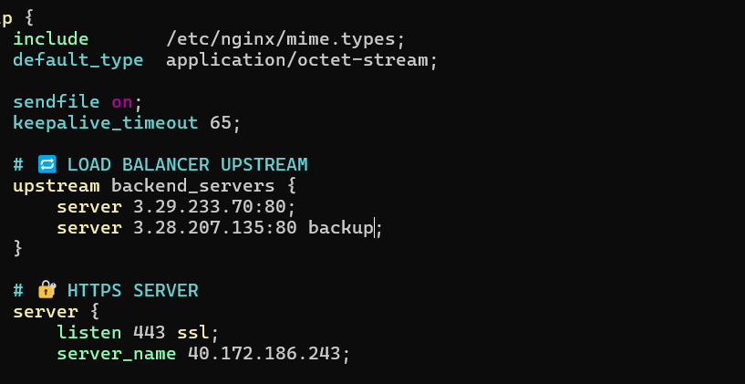

1. Restart Nginx:

sudo systemctl restart nginx

Test in browser:

Open browser and navigate to https://<webserver-public-ip>

Reload multiple times

You should ONLY see web-1 (primary server)

Save screenshot as: task9_ha_web1_only.png — browser showing only web-1 content on multiple reloads.

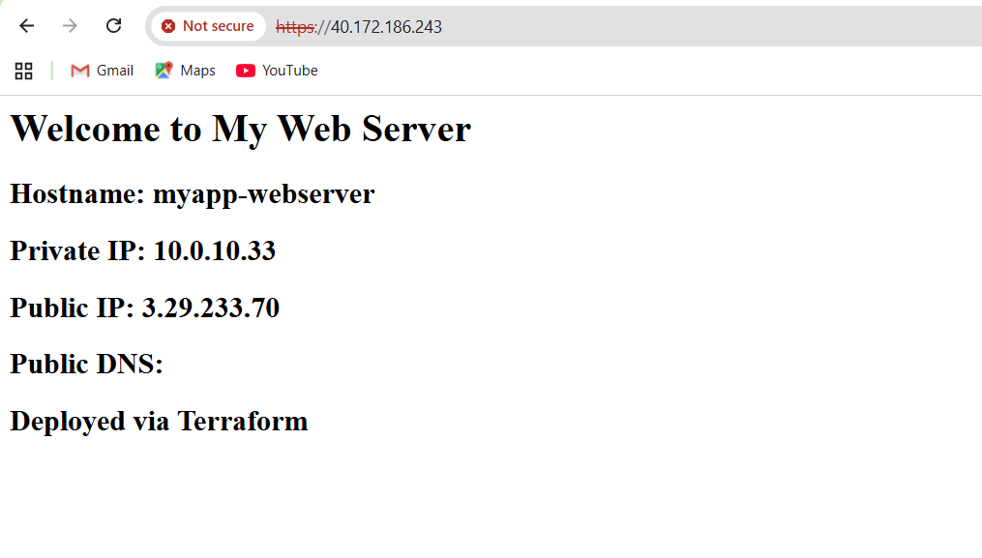

1. Switch backup configuration:

sudo vim /etc/nginx/nginx.conf

Update to make web-1 backup:

upstream backend_servers {

server <web-1-public-ip>: 80 backup;

server <web-2-public-ip>:80;

}

Save screenshot as: task9_nginx_conf_ha_web2_primary.png — nginx.conf with web-1 as backup.

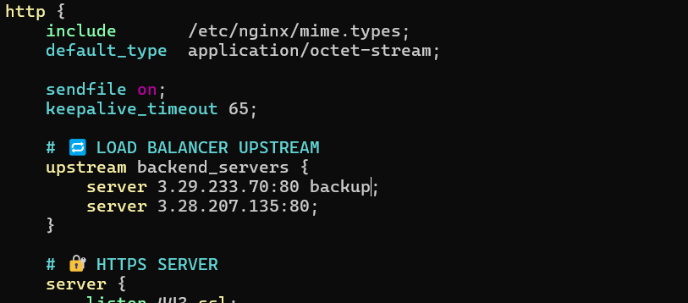

1. Restart Nginx:

sudo systemctl restart nginx

Test in browser:

Reload multiple times

You should ONLY see web-2 (now the primary server)

Save screenshot as: task9_ha_web2_only.png — browser showing only web-2 content on multiple reloads.

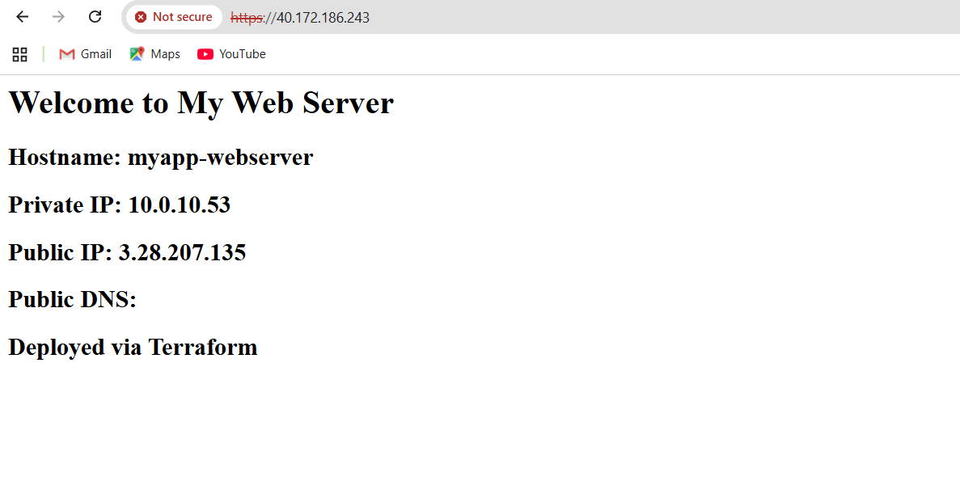

Task 10 — Enable Nginx caching

1. SSH into the webserver:

ssh ec2-user@<webserver-public-ip>

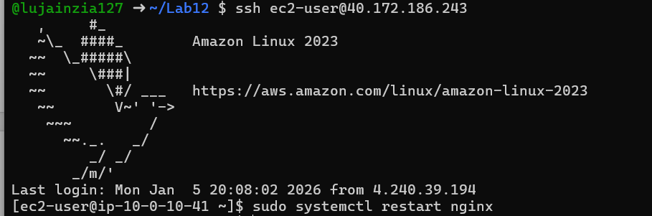

1. Edit Nginx configuration to enable caching:

sudo vim /etc/nginx/nginx.conf

Add proxy cache configuration in the http block and location block:

http {

proxy_cache_path /var/cache/nginx levels=1:2 keys_zone=my_cache:10m inactive=60m max_size=1g;

log_format main '$remote_addr - $remote_user [$time_local] "$request" '

'$status $body_bytes_sent "$http_referer" '

'"$http_user_agent" "$http_x_forwarded_for"';

# ... other settings ...

upstream backend_servers {

server <web-1-public-ip>:80;

server <web-2-public-ip>: 80;

}

server {

listen 443 ssl;

server_name $PUBLIC_IP;

ssl_certificate /etc/ssl/certs/selfsigned.crt;

ssl_certificate_key /etc/ssl/private/selfsigned.key;

location / { # root /usr/share/nginx/html; # index index.html; # proxy_pass http://<web-1-public-ip>: 80;

proxy_pass http://backend_servers;

proxy_cache my_cache;

proxy_cache_valid 200 60m;

proxy_cache_key "$scheme$request_uri";

add_header X-Cache-Status $upstream_cache_status;

}

}

# ... rest of config ...}

Save screenshot as: task10_nginx_conf_cache.png — nginx.conf showing cache configuration.

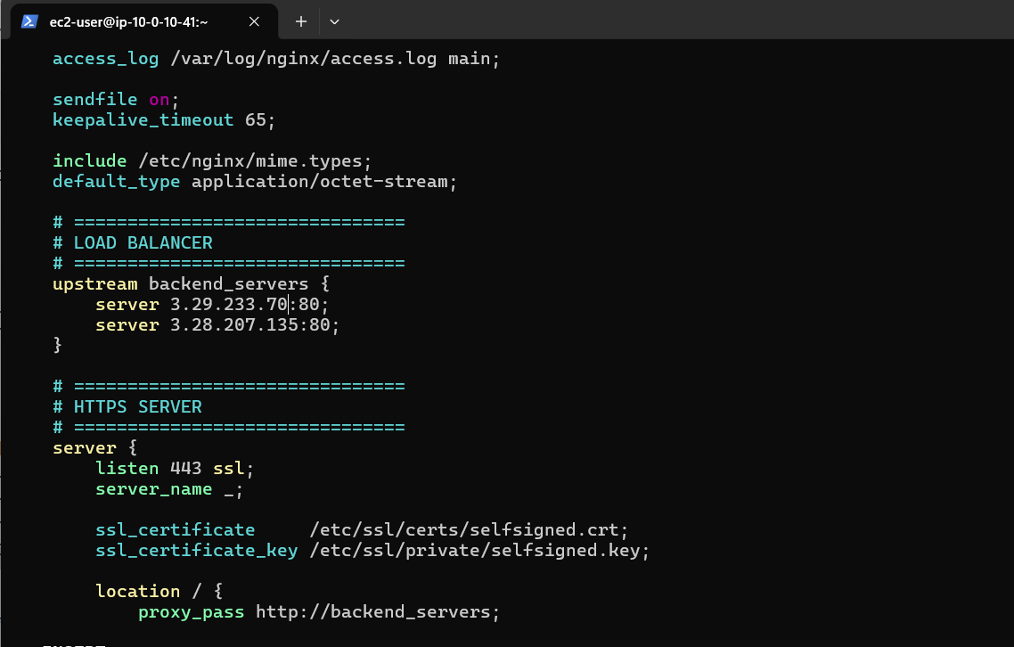

1. Restart Nginx:

sudo systemctl restart nginx

Save screenshot as: task10_nginx_restart.png — terminal showing nginx restart.



1. Test caching in browser:

Open browser developer tools (F12)

Navigate to Network tab

Visit https://<webserver-public-ip>

Check response headers for X-Cache-Status

First request should show MISS

Reload the page

Second request should show HIT

Save screenshot as: task10_cache_miss.png — browser dev tools showing X-Cache-Status: MISS on first request.



Save screenshot as: task10_cache_hit.png — browser dev tools showing X-Cache-Status: HIT on subsequent request.\

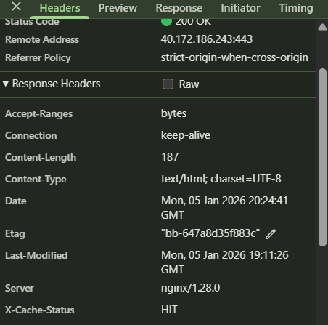

1. Verify cache directory:

ls -la /var/cache/nginx/

Save screenshot as: task10_cache_directory.png — terminal showing cache directory contents.

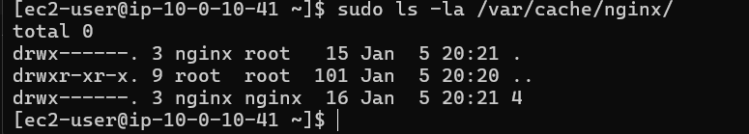

Cleanup:

1. Exit SSH session:

Exit

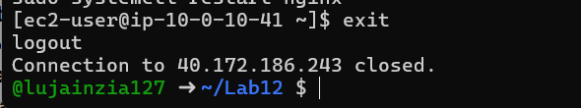

1. Destroy all resources:

terraform destroy

Type yes when prompted for confirmation.

Save screenshot as: cleanup_destroy_prompt.png — terminal showing terraform destroy prompt.

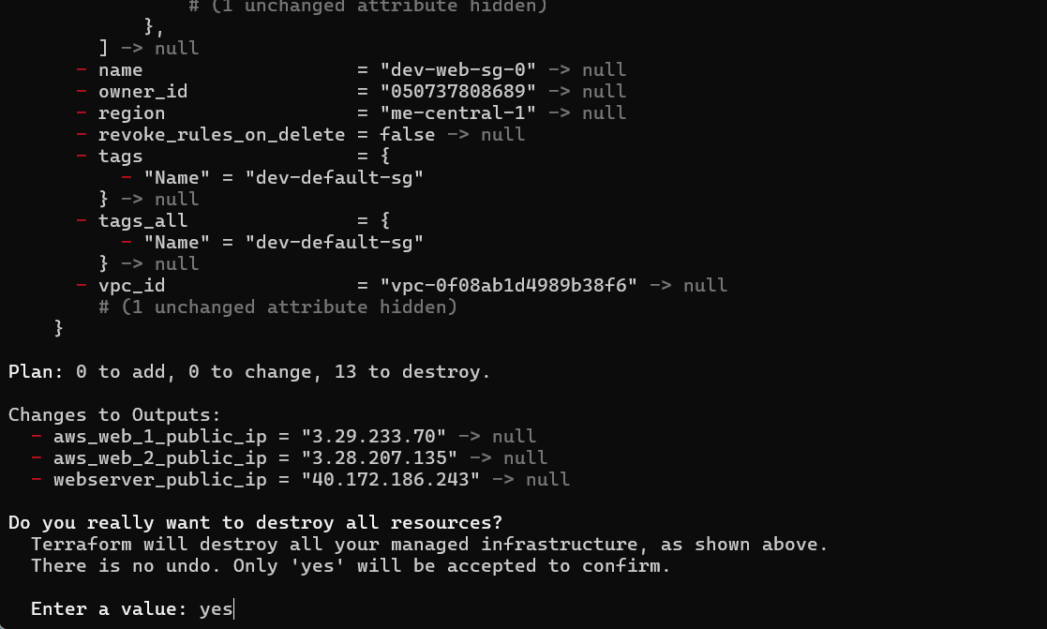

Save screenshot as: cleanup_destroy_complete.png — terraform destroy completion output.

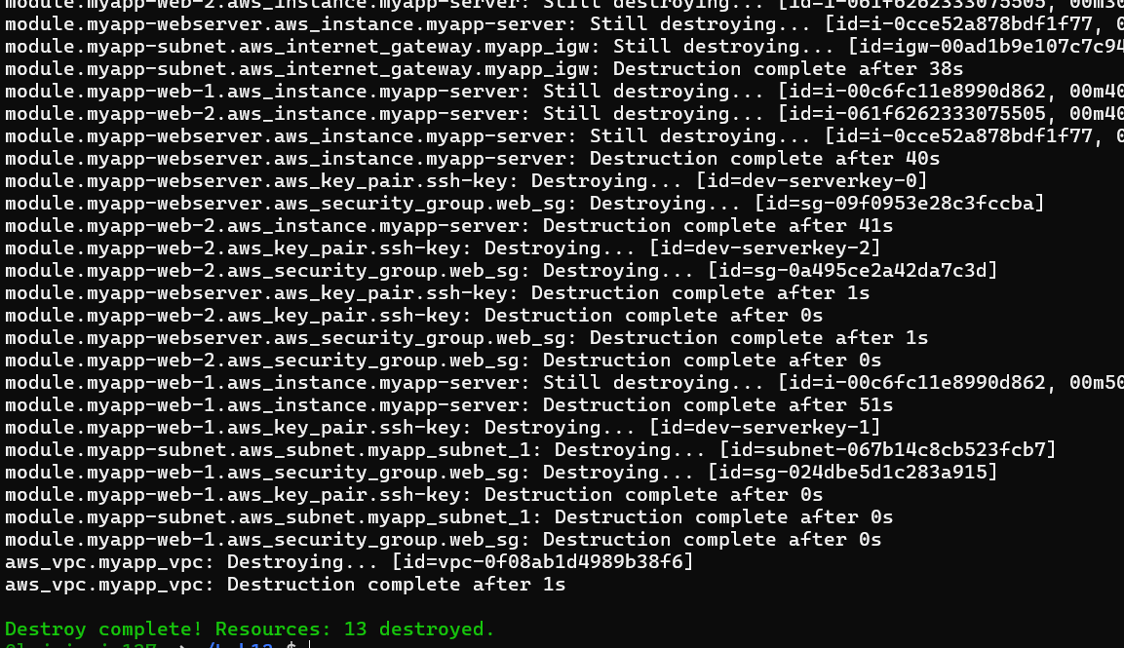

1. Verify state files:

cat terraform.tfstate

Save screenshot as: cleanup_state_empty.png — showing empty terraform. tfstate.

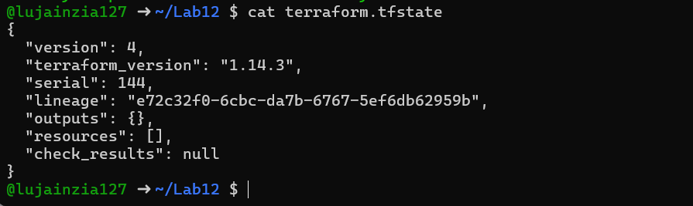

1. List all project files:

tree# or

ls -la

Save screenshot as: cleanup_final_files.png — showing final project structure.

